Year 1/2 Autumn

History/Geography:
Half term 1 – The Great Fire of London
Half term 2 – Around the World
Science:
Half term 1- Our Body (Animals including humans)
Half term 2- Seasonal Changes

English
Half term 1
The Disgusting Sandwich (Fiction) 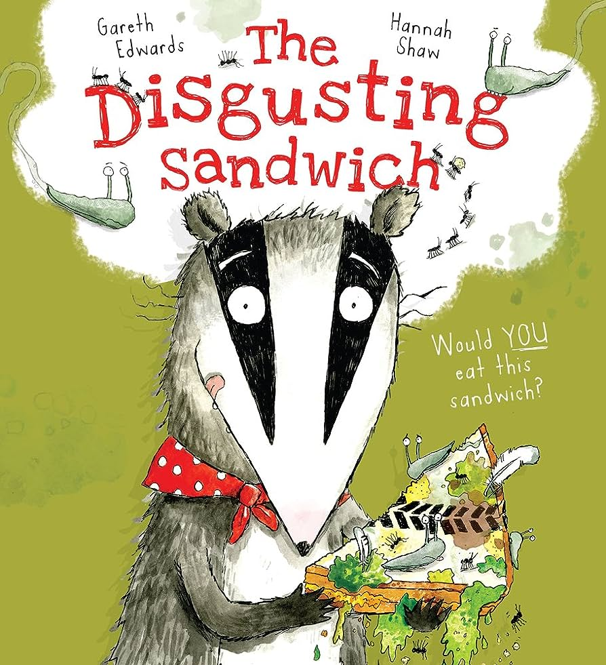 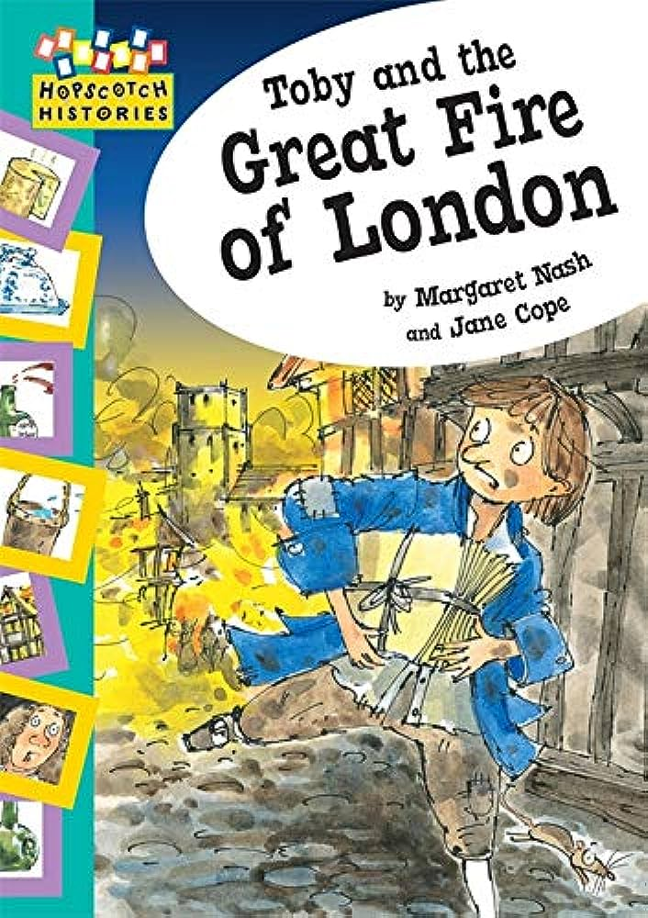
Toby and the Great Fire of London (Fiction)
Half term 2
Hibernation Hotel (Fiction)
‘Twas the night before Christmas (Poetry)
Please note, these focus books may change to follow children’s learning interests.
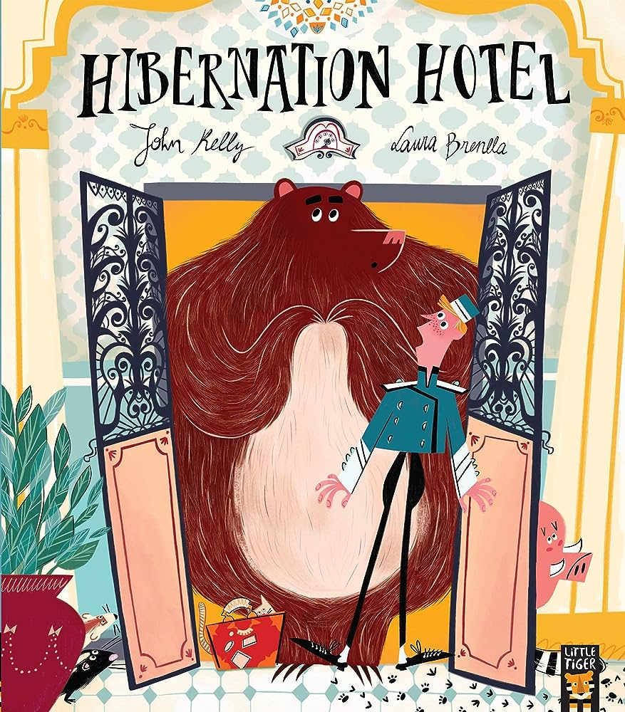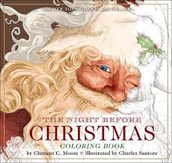
Maths
This term we will be looking at:
Y1
Place value within 10
Add and subtract within 10
Shape
Y2
Place value
Add and Subtract 100
Money
Multiplication & Division
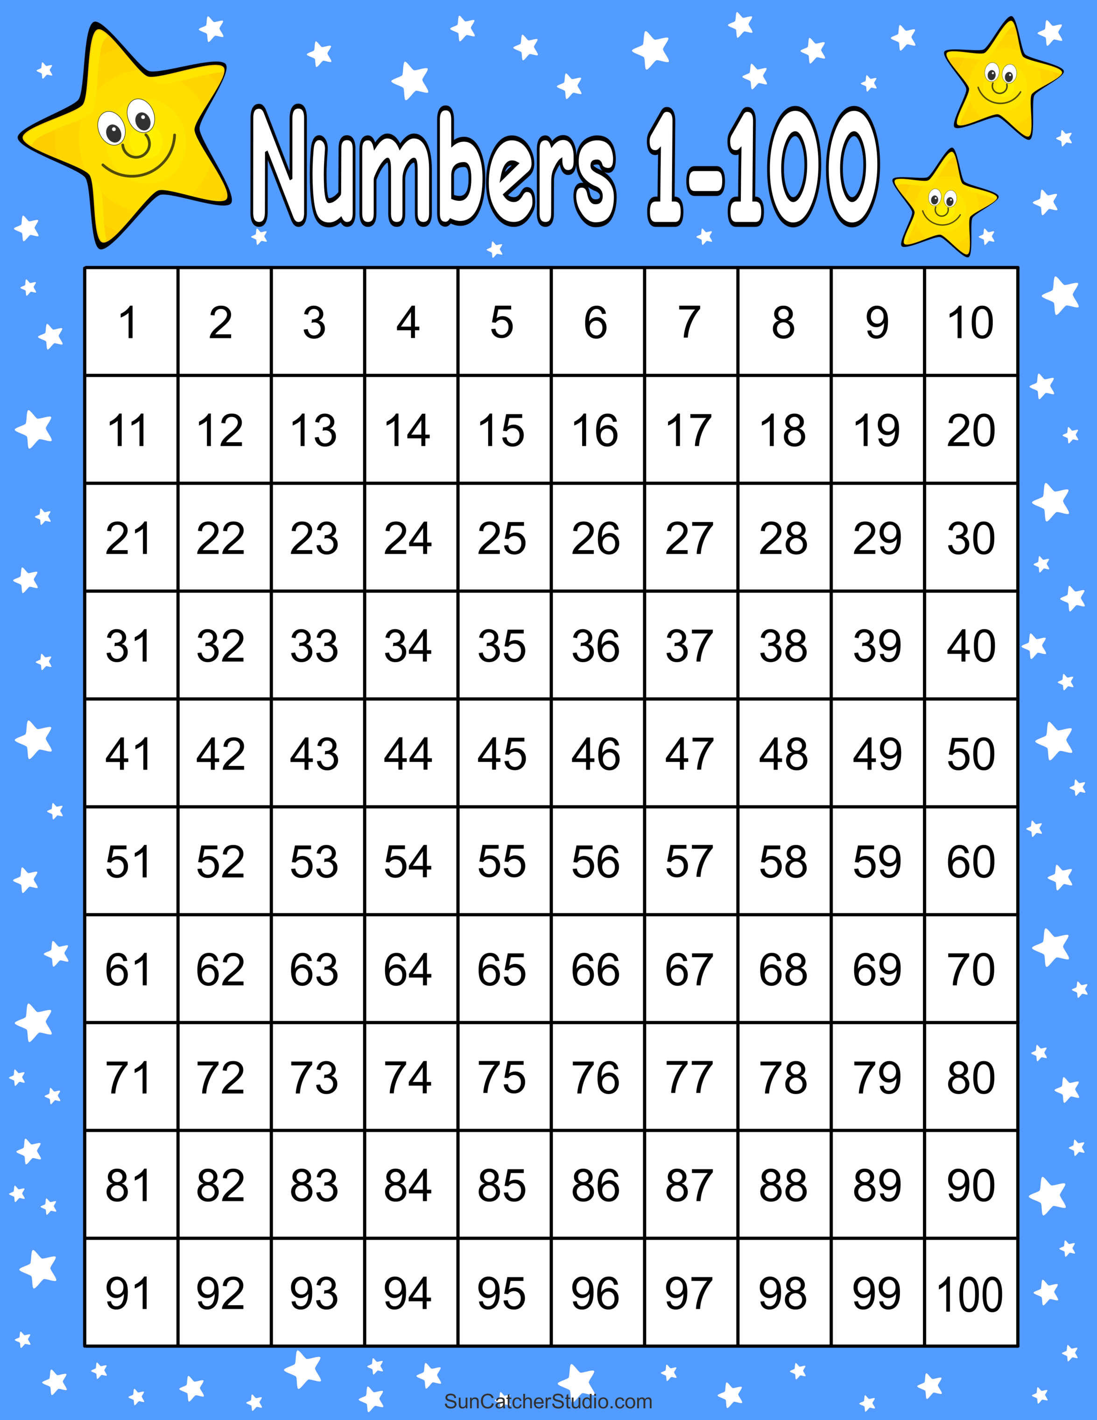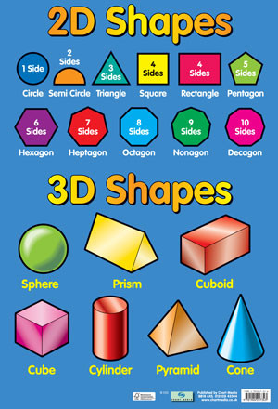

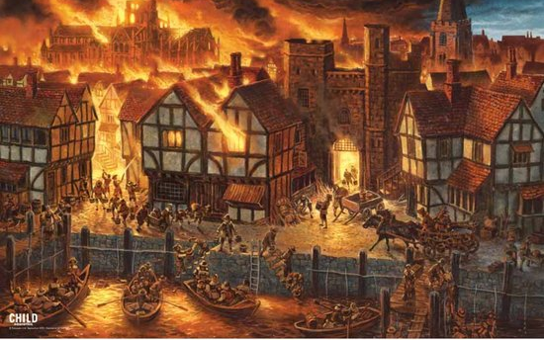
PSCHE – Me and My Relationships & Keeping Myself Safe
P.E – Tag Rugby & Dodgeball
Computing – E-Safety & Technology Around us
Art and Design – Self Portraits & Yayoi Kusama (Art) / Sparks and flames (DT)
Music – Creating and developing musical ideas (Create and Compose)
R.E – Christianity

