English
Half term 1:
Grandad’s Secret Giant (Fiction)
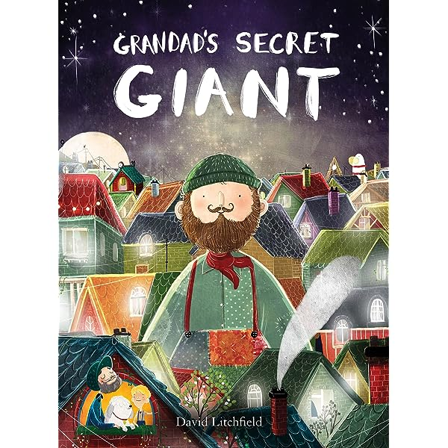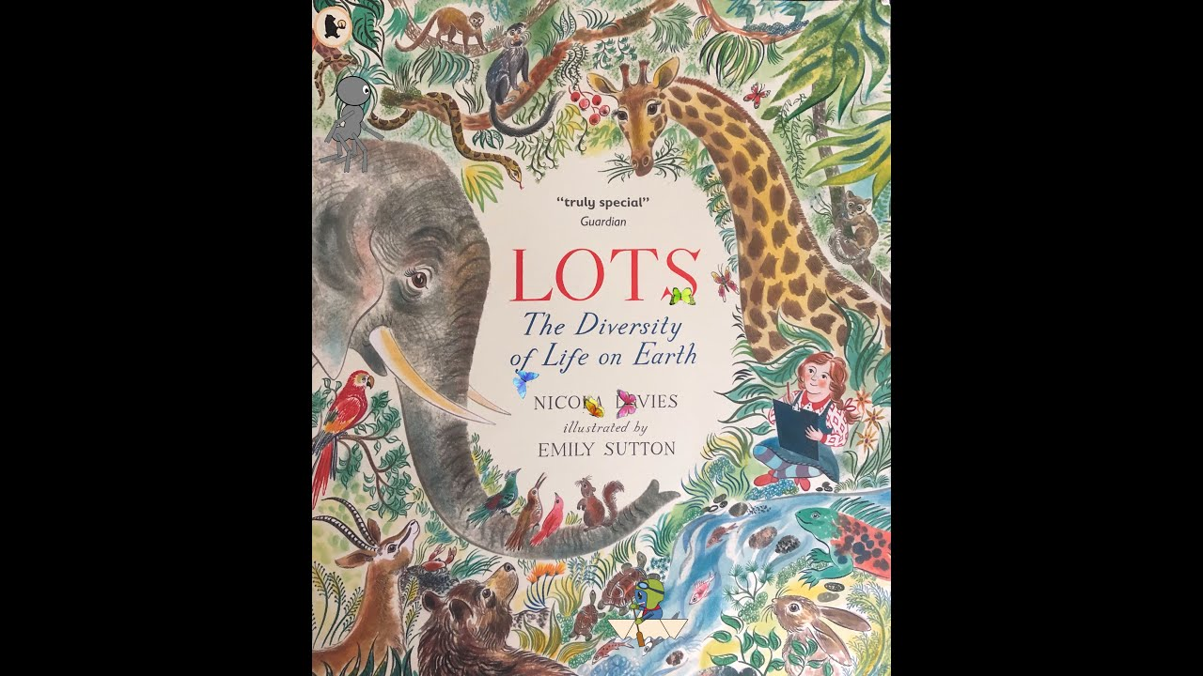
Lots-The Diversity of Life on Earth (Non-Fiction)
Half term 2:
Meerkat Mail (Fiction)
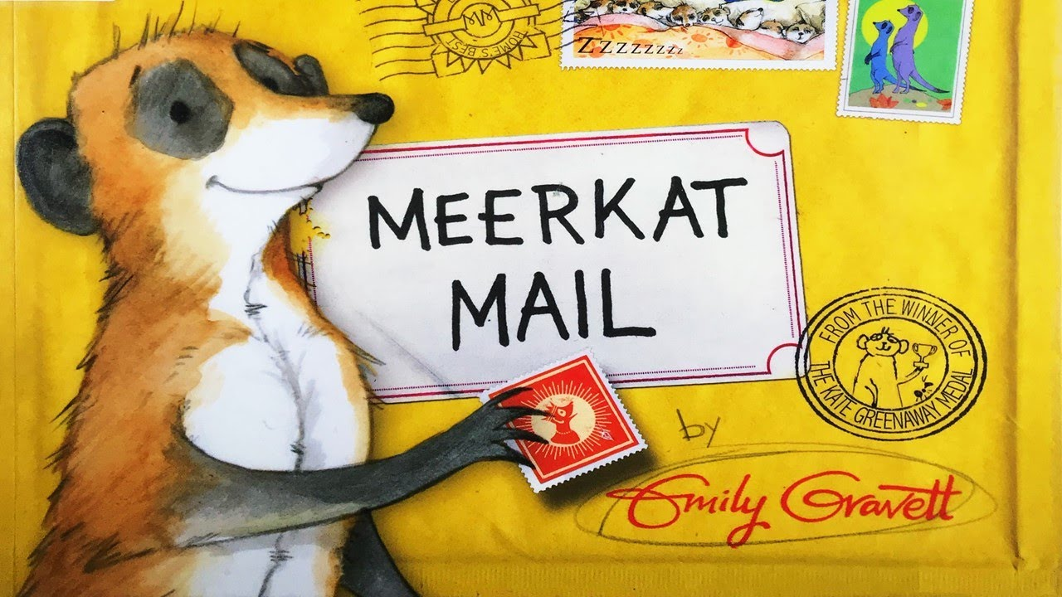
Please note, these focus books may change to follow children’s learning interests.

History/Geography:
Half term 1– World War 2 & Captain Sir Tom Moore
Half term 2– Amazing Africa
Science:
Half term 1- Animal Classification & Food Chains
Half term 2- Habitats

Maths
This term we will be looking at:
Y1
Place value within 20
Addition and subtraction within 20
Place value within 50
Length and Height
Mass and Volume

Y2
Money
Multiplication and Division
Length and Height
Mass, Capacity and Temperature

Year 1/2 Spring Term

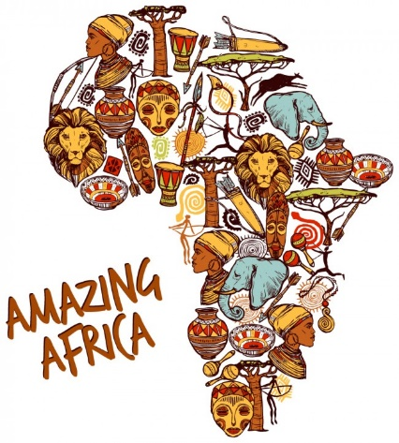

PSCHE – Growing and changing / Being my best
P.E – Football / Tennis
Computing – Programming - ScratchJr
Art and Design – Earth Art- Andy Goldsworthy & Frida Kahlo / African Art- Esther Mahlangu & Lorna Simpson
Music – Play tuned and untuned instruments musically / Easter Service
R.E – Why is Easter important to Christians? / Who is Jewish and how do they live?

