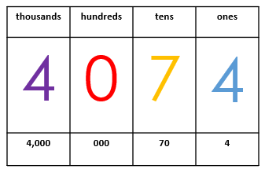
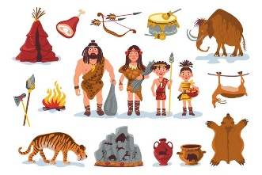
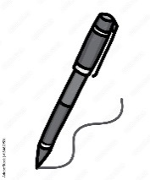
English
This half term we will be looking at:
Half term 1
- Esio Trot
- Madam Pamplemousse and Her Incredible Edibles
Half term 2
- Mr Penguin and the Lost Treasure
- Christmas poetry
We will read each focus text in class and complete a series of lessons around it. The children will write a range of fiction, non-fiction and poetry pieces of writing during this term.
Maths
This term we will be looking at:
- Number - Place Value
- Number – Addition and Subtraction

- Number – Multiplication and division

- Area (Y4 only)

Class 3 Autumn Term

History
Half term 1 – Stone Age
to Iron Age

Geography
Half term 2 – The living planet

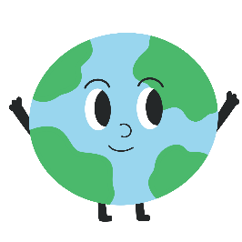

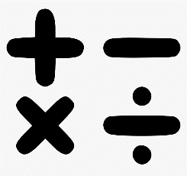
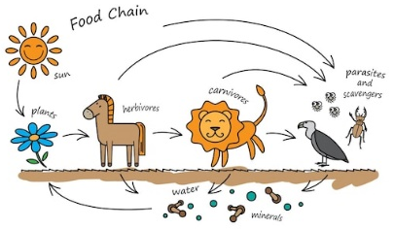
Science
This half term we will be looking at:
Half term 1- Habitats and Food Chains
Half term 2- Light and Shadow

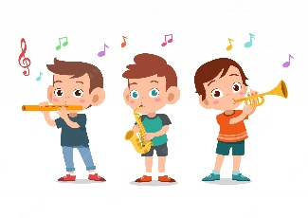
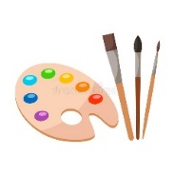
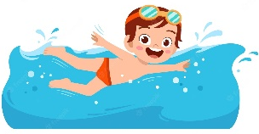

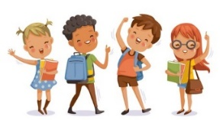
PSCHE – Me and my relationships and Keeping myself safe
P.E – Swimming, Tag Rugby and Dodgeball
Computing – Project Evolve (Online Safety)
Art and DT - Autumn Art (Matisse and Cezanne) and Photo frames (structures)
Music – Play and perform in solo and ensemble contexts, using their voices and playing musical instruments with increasing accuracy, fluency, control and expression
R.E – Hinduism - What do Hindus believe God is like? Languages: Ma Famile (My family) and Les Vacances (Holidays)
Christianity - What is it like for someone to follow God?

