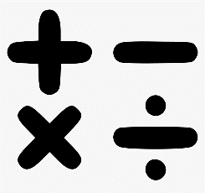
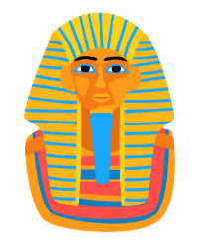
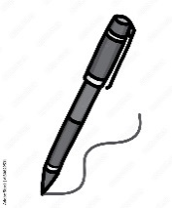
English
This half term we will be looking at:
Half term 1
- Fantastic Mr Fox
- Tadeo Jones (film unit)
Half term 2
- The Black Hat
- Rumblestar
We will read each focus text in class and complete a series of lessons around it. The children will write a range of fiction, non-fiction and poetry pieces of writing during this term.
Maths
This term we will be looking at:
- Multiplication and Division
- Length and Perimeter
- Fractions A
- Mass and Capacity (Y3)
- Decimals (Y4)

Class 3 Spring Term

History
Half term 1 – Ancient Egypt

Geography
Half term 2 – Using maps

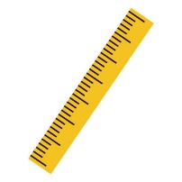

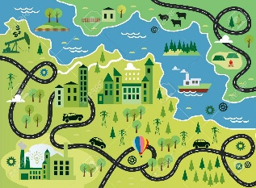
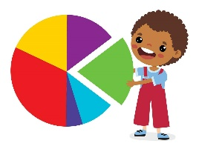
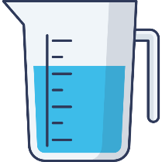


Science
This half term we will be looking at:
Half term 1- Sound
Half term 2- Electricity


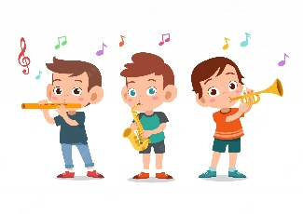
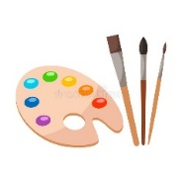



PSCHE – Growing and changing and being my best
P.E – Swimming, Football and Tennis
Computing – Stop Frame Animation
Art and DT - Sarah Taylor Blow Painting and Levers and Linkages (Easter Cards)
Music – Improve and compose music for a range of purposes using the interrelated dimensions of music and learning to play the recorder
R.E – Hinduism - What does it mean to be a Hindu in Britain today? Languages: Quelle heure est-il? (What time is it?)
Christianity - Why do Christians call the day Jesus died ‘Good Friday’? Le Zoo (The Zoo)
(The Zoo)

