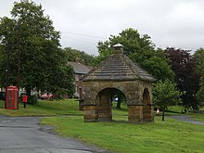
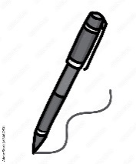
English
This half term we will be looking at:
Half term 1
- Nonsense Poems
- Rumblestar
Half term 2
- The Worst Witch
- The Firework Maker’s Daughter
We will read each focus text in class and complete a series of lessons around it. The children will write a range of fiction, non-fiction and poetry pieces of writing during this term.
Maths
This term we will be looking at:
- Mass and Capacity (Y3)
- Decimals (Y4)
- Fractions B (Y3)
- Money
- Time
- Shape
- Statistics
- Position and Direction (Y4)

Class 3 Summer Term

History
Half term 1 – Local History

Geography
Half term 2 – Mountains

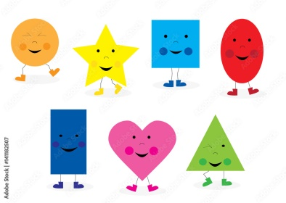

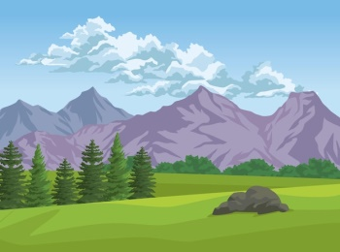

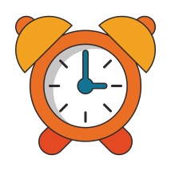
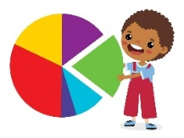
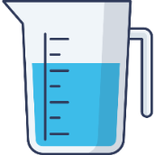
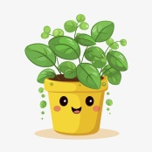
Science
This half term we will be looking at:
Half term 1- Plants
Half term 2- Forces and Magnets

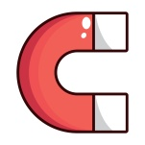
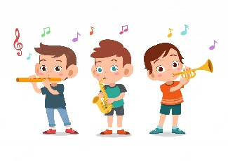
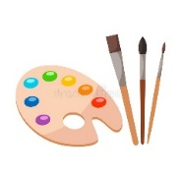
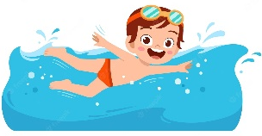

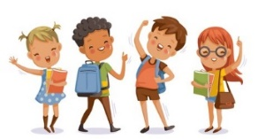
PSCHE – Rights and respect and valuing differences
P.E – Swimming, Athletics and Striking and Fielding
Computing – Micro:bit
Art and DT - Dragon Eyes (Clay) and British Inventors (Exploring famous inventions and the impact they have on our lives)
Music –Begin to develop an understanding of the history of music and learning to play the recorder
R.E – Multi-faith (How and why do people try to make the world a better place?) Languages: A l’Ecole (At School)
Christianity (For Christians,] when Jesus left, what was the impact of the Pentecost?) Allons aux magasins! (Let’s go to the shops)
(The Zoo)

