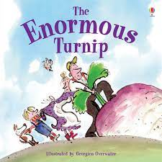
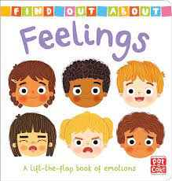
Mathematics
This term we will be looking at:
Pattern
- Notice patterns and arrange things in patterns.
- Talk about and identify the patterns around them. For example: stripes on clothes, designs on rugs and wallpaper. Use informal language like ‘pointy’, ‘spotty’, ‘blobs’, etc.
- Extend and create ABAB patterns – stick, leaf, stick, leaf.
- Notice and correct an error in a repeating pattern.
- Begin to describe a sequence of events, real or fictional, using words such as ‘first’, ‘then...’
Matching and Sorting
- Notice patterns and arrange things in patterns.
- Complete inset puzzles/jigsaws
- Match two of the same objects even if they are different sizes or colours
- Match an item to a photograph of the same item
- Match an item to its ‘shadow’
- Select shapes appropriately: flat surfaces for building, a triangular prism for a roof, etc.

Communication and Language Development/Literacy
This term we will be looking at:
- Understand single words in context – ‘cup’, ‘milk’, ‘daddy’.
- Understand frequently used words such as ‘all gone’, ‘no’ and ‘bye-bye’.
- Understand simple instructions like “give to nanny” or “stop”. Recognise and point to objects if asked about them.
- Make themselves understood and can become frustrated when they cannot.
- Enjoy listening to longer stories and can remember much of what happens.
- Pay attention to more than one thing at a time, which can be difficult.
- Use a wider range of vocabulary.
- Understand an instruction that has two parts.

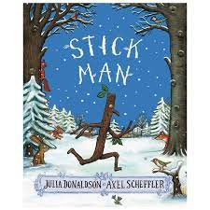
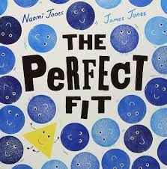

Personal, Social and Emotional Development - Marvellous Me, I’m Special, People who are Special to me, Me, my friends and family.
Physical Development – Moving and using space. Kicking, throwing & catching balls. Using large & small motor skills to do things independently. Using one-handed tools with increasing confidence. Clap and stamp to music, fit into spaces, like tunnels and dens, enjoy starting to kick, throw and catch balls.
Expressive Arts and Design – Junk modelling, transient art, food preparation, colour mixing. Take part in action songs and rhyme time. Draw with increasing complexity show different emotions in their drawings & paintings (happiness, sadness, fear).
R.E. – Making Friends, Special Books, Diwali, The Christmas Story
Understanding the World
- Autumn/Winter - explore seasons/weather
- Making connections between the features of our family
- and others
- Noticing differences between people
- Use all of our senses in hands-on exploration of
- different natural materials
- Explore collections of materials with similar or different properties

