Mathematics
This term we will be looking at:
- I can make a tower of 5 or more blocks
- I can pour from one container to another
- I can climb and squeeze into different types of spaces.
- I am beginning to use positional language, ‘on top of’’, ‘up’, ‘down’, ‘through’.
- I can say number names in order to 5 starting at 1
- I can count a line of objects, tagging each object with a number word, to 3
- I can count an irregular arrangement of 3 objects by tagging each object with a number word
- I can count out 3 objects from a larger group
- I can automatically recognise a group of 2 objects I can automatically recognise a group of 3 objects
- I know that a group of 3 objects is still a group of 3 objects even when rearranged.
- I can continue ABAB patterns.
- I can create ABAB patterns of my own.
- I can use size words to describe the things I see.
- I can use weight words to describe the things I hold
- I can describe something as ‘longer’ or ‘shorter’ when two objects of vastly different length are laid next to each other. -I can describe something as heavier or lighter when two objects of vastly

Preschool Spring Term
Our Senses/Traditional Tales

Communication and Language Development/Literacy
This term we will be looking at:
- Listen to simple stories and understand what is happening, with the help of the pictures.
- Understand ‘why’ questions, like: “Why do you think the caterpillar got so fat?”
- Sing a large repertoire of songs.
- Know many rhymes, be able to talk about familiar books, and be able to tell a long story.
- Develop their communication but may continue to have problems with irregular tenses and plurals, such as ‘runned’ for ‘ran’, ‘swimmed’ for ‘swam’.
- Develop their phonological awareness, so that they can: spot and suggest rhymes, count or clap syllables in a word, recognise words with the same initial sound, such as money and mother.
- Repeat words and phrases from familiar stories.
- Ask questions about the book.
- Develop play around favourite stories using props.

with pre-school
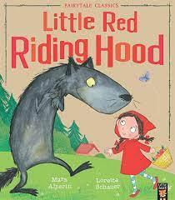
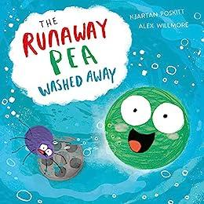

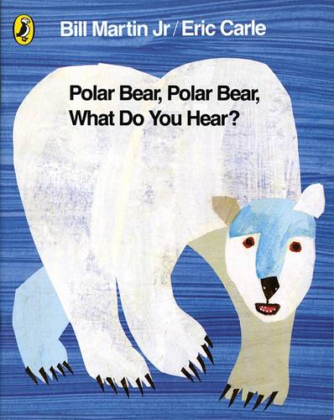
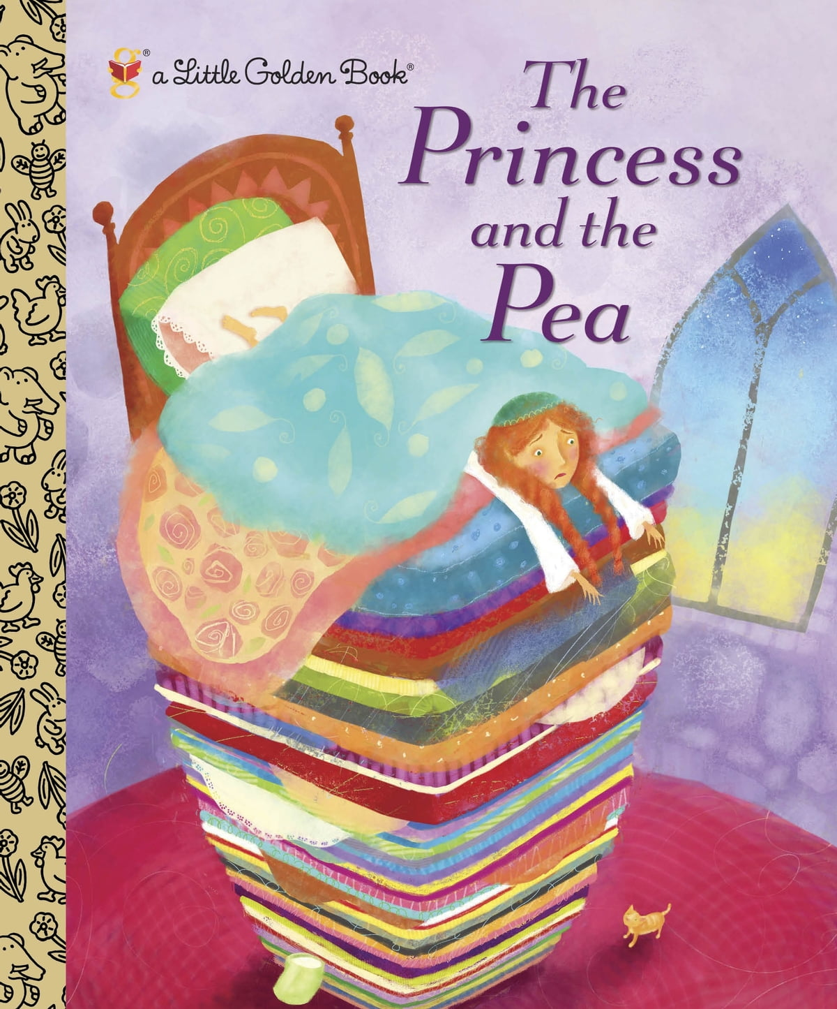
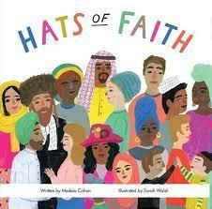
Understanding the World
Materials and their properties,
The 5 senses
Space
Seasons – Winter/Spring
Hot and cold countries
Celebrations in my home and community
Past and present linked to stories and characters

- Personal, Social and Emotional Development - Keeping my body safe, looking after our world
- Physical Development –Squiggle While You Wiggle, Dough Disco, mark making
- R.E. Why is Easter important to Christians? Why is the word ‘God’ important to Christians?
- Expressive Arts and Design – Artist, Henri Rousseau - jungle and animals, observational drawing, natural art, food preparation
- Computing-programming Code-a-pillars, creating digital art
R.E. –Being special- where do I belong? The Christmas Story, Diwali

