Mathematics
This term we will be looking at:
- Make a tower of 10 or more blocks
- Compare sizes and weights
- Compare amounts – lots, more, the same
- counting in everyday contexts
- Understand the concept of 1st, 2nd etc.
- Give objects to others with the purpose of sharing
- Say number names in order to 10
- Count 5 objects
- I can spot an error in an AB pattern
- Compare two groups – more or fewer
- I can direct a friend around an obstacle course

Communication and Language Development/Literacy
This term we will be looking at:
- Develop pronunciation of sounds
- Use longer sentences
- Start a conversation and continue it by taking turns
- Understand and act on an instruction
- Understand simple who, what and where questions
- write some or all letters in my name
- Hear the initial sound in a word
- Orally blend some words
- Enjoy drawing freely with increasing accuracy

Preschool Summer Term
Growing and Changing
Moving On

with pre-school

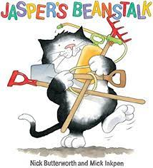
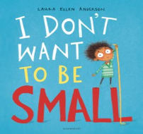

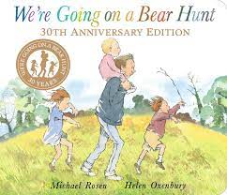
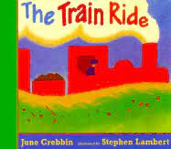
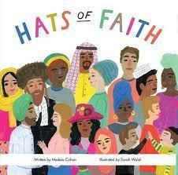
Understanding the World
Planting and growing, Life cycles
Invertebrates, Seasons – summer
Our farming community, Coastal areas
Dinosaurs, Growing Up

- Personal, Social and Emotional Development - Keeping my body healthy growth mind-set. Life stages, moving on
- Physical Development – Dance, Athletics, Squiggle Whilst You Wiggle, Dough Disco
- R.E – Valuing differences, Family, Community
- Expressive Arts and Design – Artist Kim Lewis , recycled art, sculptures, collage food preparation, moving in time
- Computing – photos and videos

