Communication and Language Development/Literacy
This term we will be looking at:

- Articulating ideas in full sentences
- Using social phrases e.g. ‘Good morning’
- Understanding how to listen and why listening is important
- Retelling stories
- Reciting favourite songs, rhymes/poems
- Identifying and saying rhyming words
- Identifying the initial sounds in words
- Recognising and saying the set 1 Read, Write, Inc. sounds
- Blending sounds to make words, e.g. sat
- Forming the letters in my name correctly
- Mark making for different purposes

Reception Autumn Term
All About Me
Celebrations/Festivals/Traditions

Mathematics
This term we will be looking at:

- Matching and sorting
- Comparing amounts
- Comparing size, mass and capacity
- Exploring pattern
- Representing 1, 2, 3
- Comparing 1-5
- Composition of 1-5
- Circles and triangles
- Positional language
- representing numbers to 5
- one more, one fewer
- Shapes with 4 sides
- Time

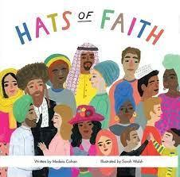
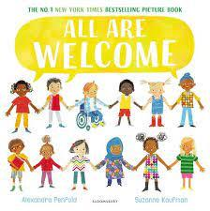
with pre-school

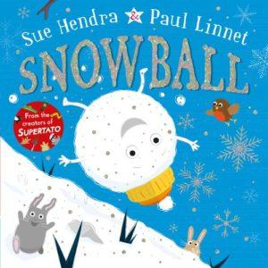
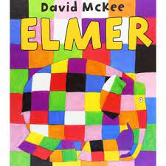

Knowledge and Understanding the World
- Autumn/winter – seasonal changes
- Animals and their habitats
Exploring rural and urban areas,
simple maps
Celebrations around the world
- E Safety, discovering computers, Code-a-pillars

Personal, Social and Emotional Development - Me and My Relationships, Valuing Difference
Physical Development –Tag rugby and invasion skills. Developing fine motor control and hand/eye coordination. Using equipment safely. Managing own hygiene, with increasing independence.
Expressive Arts and Design –Alma Thomas – patterns in art, transient art, bonfire art, food preparation – autumn vegetable soup, apple crumble, creating with paper, large construction
R.E. –Being special- where do I belong? The Christmas Story, Diwali

