Mathematics
This term we will be looking at:
- Find, subitise, represent 0 to 5
- Conceptual subitising to 5
- Explore and compare capacity and mass
- Find and represent 6,7, 8, 9 and 10
- 1 more, 1 less
- Composition of 6, 7, 8, 9 and 10
- Make pairs – odds and evens
- Double to 10 – find and make doubles
- Explore and compare length, height
- Order and sequence time
- Number bonds to 10
- Explore 3D shapes

Reception Spring Term
Our Senses
Traditional Tales

Communication and Language Development/Literacy
This term we will be looking at:
- Apply new language from books to first hand situations
- make a prediction about what happens next
- Orally retell a simple story
- Recognise all set 1 and most set 2 digraphs in words
- Read a simple sentence
- Recognise common exception words
- Write CVC words and short captions
- Hold pencil with a static tripod grip
- Form a number of clearly identifiable letters to communicate meaning.

- Hold pencil with a static tripod grip.

with pre-school
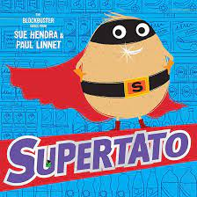
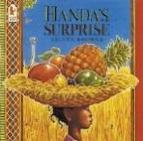

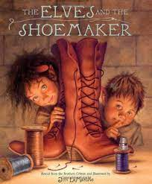
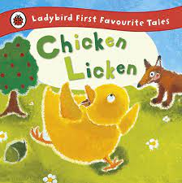
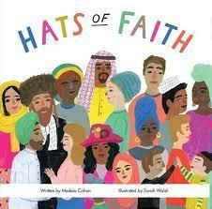
Understanding the World
Materials and their properties, the 5 senses, space
Seasons – winter/spring
Hot and cold countries
Celebrations in my home and community
Past and present linked to stories and characters

E Safety, discovering computers, Code-a-pillars
- Personal, Social and Emotional Development - Keeping my body safe, looking after our world
- Physical Development –Football and tennis skills. Control the size of my writing. Form most letters correctly.
- R.E. Why is Easter important to Christians? Why is the word ‘God’ important to Christians?
- Expressive Arts and Design – Artist, Henri Rousseau - jungle and animals, observational drawing, natural art, food preparation, nursery rhymes
- Computing-programming Code-a-pillars, creating digital art
R.E. –Being special- where do I belong? The Christmas Story, Diwali

