Communication and Language Development/Literacy
This term we will be looking at:
- Share ideas and feelings about a story
- Know the different elements of a book – cover, blurb etc.
- Read common exception words
- Increase reading fluency
- Recognise all set 1 and 2 sounds
- Write 2 or 3 linked sentences
- Consistently use capital letters, full stops and finger spaces
- Name and write the letters of the alphabet
- Use adjectives in writing to describe
- Invent own compositions

Reception Summer Term
Growing and Changing
Moving On

Mathematics
This term we will be looking at:
- Verbally counting beyond 20
- Building numbers to 20 and beyond
- Continuing number patterns
- Adding and taking away
- Manipulating and rotating shapes
- Sharing and grouping
- Identifying units of repeating patterns
- creating pattern rules
- building scenes and constructions
- making connections and deepening understanding
- Consolidating previous learning

with pre-school
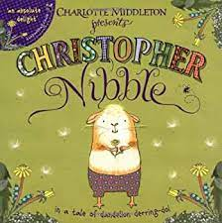
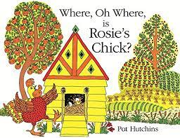

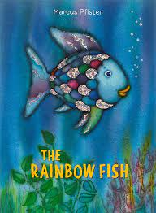
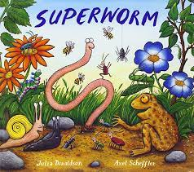
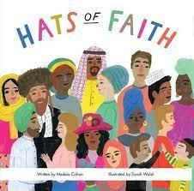
Understanding the World
Planting and growing, Life cycles
Invertebrates, Seasons – summer
Our farming community, Coastal areas
Dinosaurs, Growing Up

- Personal, Social and Emotional Development - Keeping my body healthy growth mind-set. Life stages, moving on
- Physical Development - Athletics. Striking and Fielding. Form all letters correctly and write on the line
- R.E. - Which stories and places are special and why?
- Expressive Arts and Design – Artist Kim Lewis , recycled art, sculptures, collage food preparation, moving in time
- Computing – photos and videos

