
Stamfordham Primary School
Preschool Curriculum Long Term Overview

Our school vision and values | Learning, Caring and Achieving Together – Resilient, Ambitious, Nurturing (RAN)
British values in EYFS | Democracy –voting for books to read, we make decisions together, we take turns and share, we value everyone’s ideas
British values in EYFS | Rule of Law – we take care of our classroom, we learn to resolve conflicts appropriately, we learn about right and wrong
British values in EYFS | Respect and Tolerance – we learn that we are part of a wider community, we have strong links with our community, we listen to each other
British values in EYFS | Individual Liberty – we ask questions, we celebrate our achievements, we develop our own interests and ideas
 | Autumn 1 |  |  | Autumn 2 |  | Spring 1 |  |  | Spring 2 |  | Summer 1 |  | Summer 2
Parents as Partners | Stay and Play |  |  | Share a book  Christmas play  Parent consultations |  | Share a Skill |  |  | Open Afternoon  Easter service |  | Breakie and a Book |  | Book Look  Graduation  Sports Day
Visits/visitors | Stamfordham community walk  Adam Bushnell (author) |  |  | Pantomime  Baptism at St Mary’s Church (3 & 4 yr olds) |  | Spring Observational Village Walk  Share a Skill |  |  | Easter Service  Bolam Lake |  | Whitehouse Farm |  | Summer Observational Village walk  Visit to the Park
Woodland School | Den building  Making rainbows with leaves & mud  Nature paintbrushes/ broom |  |  | Animal habitats  Nature walk treasure hunt  Mud hedgehogs |  | Bug scavenger hunt  Wonderful Winter collages (pine cones, acorns, conkers, dried grasses, rocks, twigs etc). |  |  | Fairy garden  Listening tree |  | How to be safe in the fire circle  Singing songs, reading stories around fire  Toasting marshmallows |  | Fire safety and cooking (smores, bananas & chocolate,popcorn, bread)
Half Termly Focus | All about me |  |  | Celebrations/  Festivals/  Traditions |  | Our Senses |  |  | Traditional Tales |  | Growing and Changing |  | Moving on
Core books | 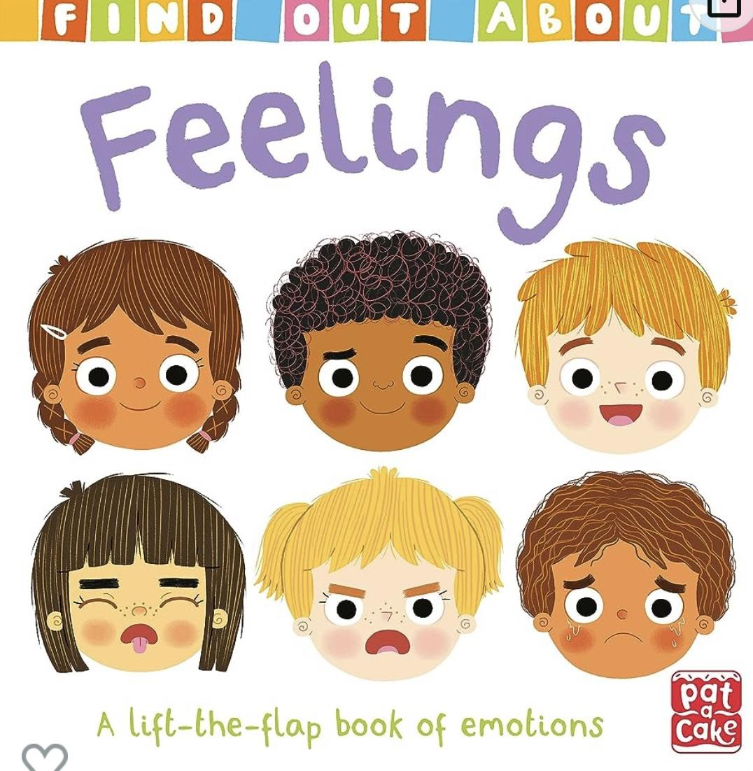 |  |  | 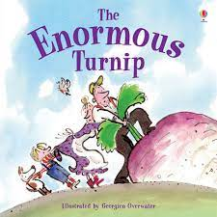 |  | 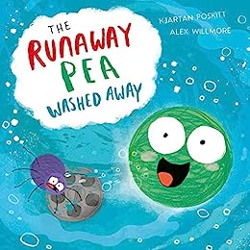 |  |  | 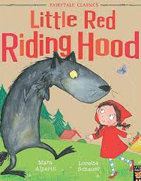 |  | 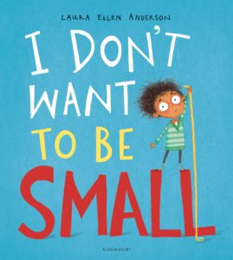 |  | 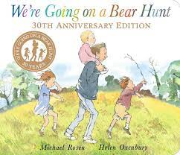
Core books | 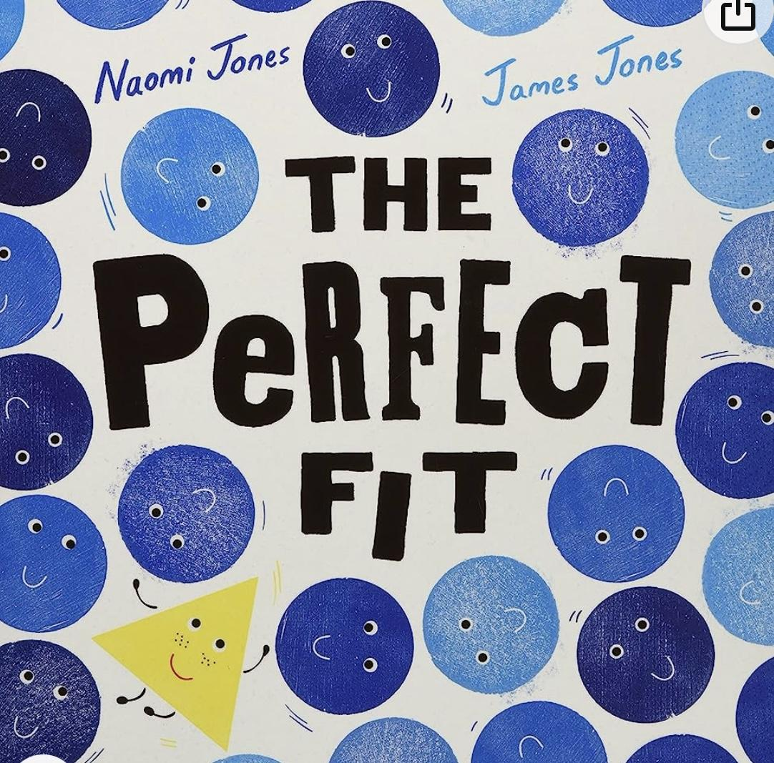 |  |  | 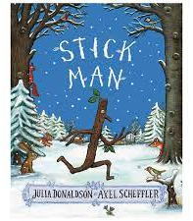  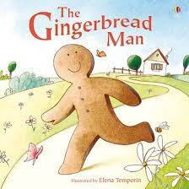 |  | 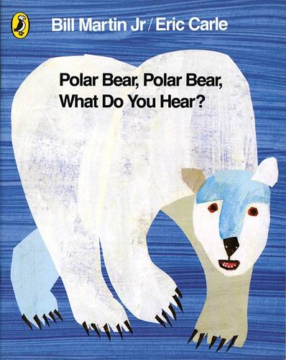 |  |  | 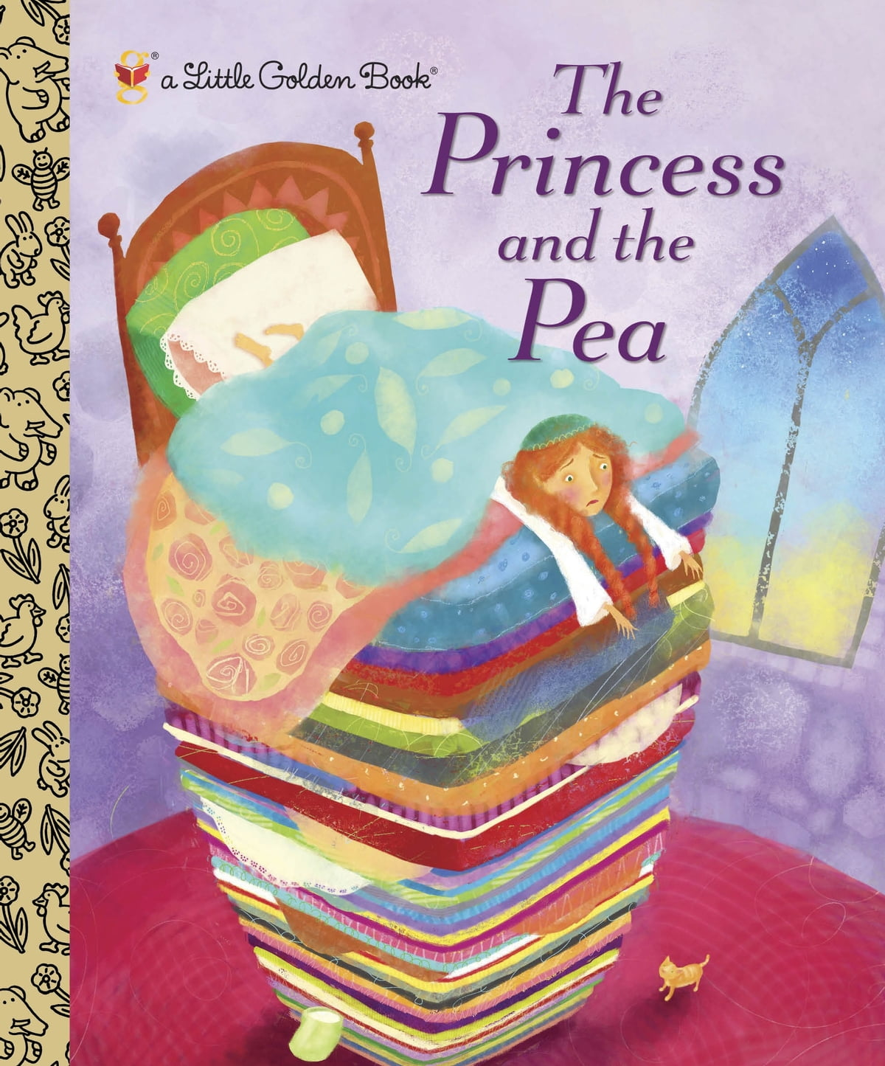 |  | 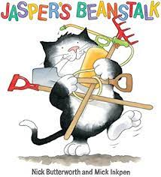 |  | 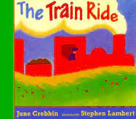
Linked texts | Oh Dear Geoffrey  The Colour Monster |  |  | Celebrate the World: Diwali  Aliens Love Panta Claus |  | Brown Bear, Brown Bear  What the Ladybird Heard |  |  | Each Peach Pear Plum  Hansel and Gretal |  | Jack & the Beanstalk  Titch |  | I wish I could Roar!  I wish I could Dance!
Core Poems | Chop Chop  Pointy Hat |  |  | 5 Little Pumpkins  Wise Old Owl |  | Pancakes  Let’s Put On Our Mittens |  |  | Spring Wind  Furry Furry Squirrel |  | I Have a Little Frog  The Fox |  | Thunderstorm  If I Were So Very Small
Core Songs and Rhymes | Busy for the Harvest  5 Little Peas  Big Red Combine Harvester |  |  | Christmas Pudding  Tommy Thumb is up  Away in a Manger |  | My senses song  Insects all around |  |  | 5 Little Chicks  Little Peter Rabbit |  | Growing Up song  5 Little Men |  | Wind the bobbin up  Old macdonald’s Counting Farm
Communication and Language Development  2-3yrs  3-4yrs | - Understand single words in context – ‘cup’, ‘milk’, ‘daddy’.  - Understand frequently used words such as ‘all gone’, ‘no’ and ‘bye-bye’.  - Understand simple instructions like “give to nanny” or “stop”. Recognise and point to objects if asked about them.  - Generally focus on an activity of their own choice and find it difficult to be directed by an adult.  - Listen to other people’s talk with interest but can easily be distracted by other things.  - Make themselves understood and can become frustrated when they cannot.  - Start to say how they are feeling, using words as well as actions.  - Enjoy listening to longer stories and can remember much of what happens.  - Pay attention to more than one thing at a time, which can be difficult.  - Use a wider range of vocabulary.  - Understand a question or instruction that has two parts, such as: “Get your coat and wait at the door”. |  |  |  |  | - Start to develop conversation, often jumping from topic to topic.  - Develop pretend play: ‘putting the baby to sleep’ or ‘driving the car to the shops’.  - Use the speech sounds p, b, m, w. Pronounce: l/r/w/y, f/th, s/sh/ch/dz/j, multi-syllabic words such as ‘banana’ and ‘computer’.  - Listen to simple stories and understand what is happening, with the help of the pictures.  - Understand ‘why’ questions, like: “Why do you think the caterpillar got so fat?”  - Sing a large repertoire of songs.  - Know many rhymes, be able to talk about familiar books, and be able to tell a long story.  - Develop their communication but may continue to have problems with irregular tenses and plurals, such as ‘runned’ for ‘ran’, ‘swimmed’ for ‘swam’. |  |  |  |  | - Identify familiar objects and properties for practitioners when they are described: for example: ‘Katie’s coat’, ‘blue car’, ‘shiny apple’.  - Understand and act on longer sentences like ‘make teddy jump’ or ‘find your coat’.  - Understand simple questions about ‘who’, ‘what’ and ‘where’ (but generally not ‘why’).  - Develop their pronunciation but may have problems saying some sounds: r, j, th, ch, and sh, multisyllabic words such as ‘pterodactyl’, ‘planetarium’ or ‘hippopotamus’.  - Use longer sentences of four to six words.  - Be able to express a point of view and to debate when they disagree with an adult or a friend, using words as well as actions.  - Start a conversation with an adult or a friend and continue it for many turns.  - Use talk to organise themselves and their play: “Let’s go on a bus... you sit there... I’ll be the driver.”
Literacy - Comprehension, word reading, writing  2-3yrs  3-4yrs | - Enjoy songs and rhymes, tuning in and paying attention.  - Join in with songs and rhymes, copying sounds, rhythms, tunes and tempo.  - Say some of the words in songs and rhymes. Copy finger movements and other gestures.  - Sing songs and say rhymes independently, for example, singing whilst playing.  - Enjoy sharing books with an adult. Pay attention and respond to the pictures or the words.  - Understand the five key concepts about print: print has meaning, print can have different purposes, we read English text from left to right and from top to bottom, the names of the different parts of a book, page sequencing.  - Engage in extended conversations about stories, learning new vocabulary. |  |  |  |  | - Have favourite books and seek them out, to share with an adult, with another child, or to look at alone.  - Repeat words and phrases from familiar stories.  - Ask questions about the book.  - Make comments and share their own ideas.  - Develop play around favourite stories using props.  - Develop their phonological awareness, so that they can: spot and suggest rhymes, count or clap syllables in a word, recognise words with the same initial sound, such as money and mother.  - Use some of their print and letter knowledge in their early writing. For example: writing a pretend shopping list that starts at the top of the page; writing ‘m’ for mummy. |  |  |  |  | - Notice some print, such as the first letter of their name, a bus or door number, or a familiar logo.  - Enjoy drawing freely.  - Add some marks to their drawings, which they give meaning to. For example: “That says mummy.”  - Make marks on their picture to stand for their name.  - Write some or all of their name.  - Write some letters accurately.  - Recognise and say some set 1 RWI sounds  - Hear the initial sound in a word  - Orally blend some CVC words  - Begin to form some letters correctly
Personal , Social and Emotional Development Links  2-3yrs  3-4yrs | Development Matters Links  - Find ways to calm themselves, through being calmed and comforted by their key person.  - Establish their sense of self.  - Express preferences and decisions.  - They also try new things and start establishing their autonomy.  - Engage with others through gestures, gaze and talk.  - Use that engagement to achieve a goal. For example, gesture towards their cup to say they want a drink.  - Find ways of managing transitions, for example from their parent to their key person.  - Thrive as they develop self-assurance.  - Look back as they walk away from their key person. Look for clues about how to respond to something interesting.  - Play with increasing confidence on their own and with other children, because they know their key person is nearby and available.  - Feel confident when taken out around the local neighbourhood and enjoy exploring new places with their key person  - Feel strong enough to express a range of emotions.  - Grow in independence, rejecting help (“me do it”). Sometimes this leads to feelings of frustration and tantrums.  - Begin to show ‘effortful control’. For example, waiting for a turn and resisting the strong impulse to grab what they want or push their way to the front.  - Be increasingly able to talk about and manage their emotions.  - Notice and ask questions about differences, such as skin colour, types of hair, gender, special needs and disabilities, religion and so on.  - Develop friendships with other children.  - Safely explore emotions beyond their normal range through play and stories.  - Talk about their feelings in more elaborated ways: “I’m sad because…” or “I love it when …”.  - Select and use activities and resources, with help when needed. This helps them to achieve a goal they have chosen, or one which is suggested to them.  - Develop their sense of responsibility and membership of a community  - Become more outgoing with unfamiliar people, in the safe context of their setting.  - Show more confidence in new social situations.  - Play with one or more other children, extending and elaborating play ideas  - Find solutions to conflicts and rivalries. For example, accepting that not everyone can be Spider-Man in the game, and suggesting other ideas.  - Increasingly follow rules, understanding why they are important.  - Remember rules without needing an adult to remind them.  - Develop appropriate ways of being assertive.  - Talk with others to solve conflicts.  - Talk about their feelings using words like ‘happy’, ‘sad’, ‘angry’ or ‘worried’.  - Understand gradually how others might be feeling.  - Be increasingly independent in meeting their own care needs, e.g., brushing teeth, using the toilet, washing and drying their hands thoroughly.  - Make healthy choices about food, drink, activity and toothbrushing.  Reception  - See themselves as a valued individual  - Build constructive and respectful relationships  - Express their feelings and consider the feelings of others  - Show resilience and perseverance in the face of a challenge  - Identify and modify their feelings socially and emotionally  - Think about the perspectives of others  - Manage their own needs – personal hygiene  - Know and talk about the different factors that support their overall health and well-being:  - regular physical activity  - healthy eating  - toothbrushing  - sensible amounts of ‘screen time’  - having a good sleep routine  - being a safe pedestrian
Personal , Social and Emotional Development | Me and My Relationships  - Marvellous Me  - I’m Special  - People who are special to me |  | Valuing Difference  - Me and my friends  - Friends and family  - Including everybody |  | Keeping Myself Safe  - People who help me and keep me safe  - Safety indoors and outdoors  - What’s safe to go into my body |  |  | Rights and Responsibilities  - Looking after myself  - Looking after others  - Looking after the environment |  | Being My Best  - What does my body need?  - I can keep trying  - I can do it! |  | Growing & Changing  - Growing and changing in nature  - When I was a baby  - Girls, Boys and families
Physical Development Links  2-3yrs  3-4yrs | Development Matters  - Gradually gain control of their whole body through continual practice of large movements, such as waving, kicking, rolling, crawling and walking.  - Clap and stamp to music.  - Fit themselves into spaces, like tunnels, dens and large boxes, and move around in them. Enjoy starting to kick, throw and catch balls. Build independently with a range of appropriate resources.  - Begin to walk independently – choosing appropriate props to support at first.  - Walk, run, jump and climb – and start to use the stairs independently.  - Spin, roll and independently use ropes and swings (for example, tyre swings).  - Sit on a push-along wheeled toy, use a scooter or ride a tricycle. Use large and small motor skills to do things independently, for example manage buttons and zips, and pour drinks.  - Show an increasing desire to be independent, such as wanting to feed themselves and dress or undress.  - Start eating independently and learning how to use a knife and fork.  - Develop manipulation and control.  - Explore different materials and tools  - Continue to develop their movement, balancing, riding (scooters, trikes and bikes) and ball skills.  - Go up steps and stairs, or climb up apparatus, using alternate feet.  - Skip, hop, stand on one leg and hold a pose for a game like musical statues.  - Use large-muscle movements to wave flags and streamers, paint and make marks.  - Start taking part in some group activities which they make up for themselves, or in teams.  - Increasingly be able to use and remember sequences and patterns of movements which are related to music and rhythm.  - Match their developing physical skills to tasks and activities in the setting. For example, they decide whether to crawl, walk or run across a plank, depending on its length and width.  - Choose the right resources to carry out their own plan. For example, choosing a spade to enlarge a small hole they dug with a trowel.  - Collaborate with others to manage large items, such as moving a long plank safely, carrying large hollow blocks.  - Use one-handed tools and equipment, for example, making snips in paper with scissors.  - Use a comfortable grip with good control when holding pens and pencils.  - Show a preference for a dominant hand.  - Be increasingly independent as they get dressed and undressed, for example, putting coats on and doing up zips  Reception  - Show good control and coordination of large and small movements.  - Move confidently in a range of ways, safely negotiating space.  - Know the importance for good health of physical exercise, and a healthy diet, and talk about ways to keep healthy and safe.  - Show good control and coordination in large and small movements.
Physical Development (Gross/Fine Motor Skills) | Movement & using space  Squiggle whilst you wiggle  Dough Disco |  |  | Group games/activities  Squiggle whilst you wiggle  Dough Disco |  | Ball skills  Squiggle whilst you wiggle  Dough Disco |  |  | Group games/activities  Squiggle whilst you wiggle  Dough Disco |  | Dance  Squiggle whilst you wiggle  Dough Disco |  | Athletics  Squiggle whilst you wiggle  Dough Disco
Maths  2-3yrs  3-4yrs | Autumn Term  - I can combine objects like stacking blocks and cups.  - I can fill and empty containers.  - I can notice patterns and arrange things in patterns.  - I can put objects inside others and take them out again.  - I can join in with the actions to nursery rhymes.  - I can build with a range of resources.  - I can match two of the same objects even if they are different sizes or colours  - I can explore different shapes in the environment  - I can say number names in order to 3 starting at 1  - I can take part in finger rhymes with numbers – reacting to changes of amount in a group of up to 3  - I can count in everyday contexts sometimes skipping numbers or saying them in the wrong order  - I can say the correct number word when I see number symbols 1-3 in various contexts.  - I can match the number symbol with a group of up to 3 objects.  - I can split 3 objects into different groups  - I can engage in exploratory play with shapes  - I can use gesture and limited talk (e.g. ‘there’) to indicate the position of something that has been asked for.  - I can ride trikes/scooters around different routes to get to the same endpoint  - I can take part in various construction activities building 3 block bridges to join my towers together when given a model to copy  - I can use gesture and limited talk (e.g. ‘there’) to indicate the position of something that has been asked for.  - I can respond to the use of everyday positional language e.g. I put my bag under my chair, I put my lunchbox in my bag etc. -I can notice simple patterns e.g. a spotty pattern on a jumper -  - I can talk about patterns around me (e.g. the stripy pattern on a cloth)  - I can copy ABAB patterns.  - I can attempt, sometimes successfully, to fit shapes into spaces on more challenging inset boards or 10 piece jigsaw puzzles.  - I can select shapes which will fit when rotated or flipped in inset boards, shape sorters and jigsaws  - I can put things away in their correct boxes – understanding that these are the right size for the object.  - I can print and make pictures and patterns with shapes  - -I know the names of the 2D shapes circle, square, rectangle and triangle.  - I can play with a variety of different sized toys when filling/emptying containers |  |  |  |  | Spring Term  - I can make a tower of 5 or more blocks  - I can pour from one container to another  - I can climb and squeeze into different types of spaces.  - I am beginning to use positional language, ‘on top of’’, ‘up’, ‘down’, ‘through’.  - I can take part in finger rhymes with numbers up to 3  - I can complete simple inset puzzles and jigsaws  - I can develop counting-like behaviour, such as making sounds, pointing or saying some numbers in sequence.  - I can say number names in order to 5 starting at 1  - I can count a line of objects, tagging each object with a number word, to 3  - I can count an irregular arrangement of 3 objects by tagging each object with a number word  - I can count out 3 objects from a larger group  - I can automatically recognise a group of 2 objects I can automatically recognise a group of 3 objects  - I know that a group of 3 objects is still a group of 3 objects even when rearranged.  - I can split 3 objects into different groups (e.g. I can give 3 bears one spoon each, I can give mummy bear 2 spoons so she can feed baby bear and herself but daddy bear can feed himself)  - I know when I have split a set of 3 objects into groups, if I collect them back together there will still be 3.  - I can use everyday positional language in my day to day talk  - I can arrange things in patterns e.g. I can place a pompom inside the holes of an egg tray  - I can continue ABAB patterns.  - I can create ABAB patterns of my own.  - I can use size words to describe the things I see.  - I can use weight words to describe the things I hold  - I can describe something as ‘longer’ or ‘shorter’ when two objects of vastly different length are laid next to each other. -I can describe something as heavier or lighter when two objects of vastly  - I can use the phrases ‘too much’ and ‘not enough’ when filling containers.  - Different weights are compared  - I can make a tower of blocks that is the same height, taller and smaller than myself? |  |  |  |  | Summer Term  - I can make a tower of ten or more blocks  - I can match an item to a photograph of the same item  - I can react to changes of amount in a group of up to three items.  - I can compare sizes, weights etc. using gesture and language - ‘bigger/little/smaller’, ‘high/low’, ‘tall’, ‘heavy’.  - I can compare amounts, saying ‘lots’, ‘more’ or ‘same’.  - I can count in everyday contexts, sometimes skipping numbers – ‘1-2-3-5’.  - I understand the concept of first/second by telling you who the winner is in a race etc.  - I can give out objects to others with the purpose of sharing although not equally  - I can say number names in order to 10 starting at 1  - I can count a line of objects, tagging each object with a number word, to 5  - I can count an irregular arrangement of 5 objects by tagging each object with a number word  - I can say the correct number word when I see number symbols 4-5 in various contexts  - I can compare two groups (when the amounts are obviously different and the objects are of a similar size) saying where there is more and where there is less.  - I can share up to 4 objects between 2 people by dealing out 1 for 1  - I can build 3 steps with 6 cubes  - I can non-verbally make a small collection (no more than 5) with the same number of another collection eg. when shown a collection of 3, I can make another collection of 3  - I can say which number is more or less than another number with the support of objects  - I can group objects together (e.g. in a selection of 5 items of crockery group all of the cups and the plates)  - I know when I have split a set of 5 objects into groups, if I collect them back together there will still be 5.  - I can direct a friend around an obstacle course using spatial vocabulary.  - I can give simple explanations about why I have chosen a particular shape or object using everyday language for its properties e.g. I needed something flat for teddy to lie on.  - I can spot an error in an ABAB pattern and correct it.  - I can compare sizes, weights etc. using gesture (e.g. pointing or picking up) or language to indicate bigger, smaller, high, low, heavy, light  - I know it takes longer to count out a box full of tiny objects compared to the same box filled with large objects.  - I can compare a tower of multilink to an object and describe if it is the same size, longer/bigger or smaller/shorter.  - I can measure the length of objects using various measuring apparatus such as apples, multilink, metre sticks etc.
Understanding the World
Science – working scientifically | Ongoing throughout year - Have ideas. Test ideas. Notice similarities and differences. Use sense to look closely. Create simple representations of people and objects. Talk about things like plants, animals, natural and found objects. Begin to use science words. Question why things happen.
Science links  2-3yrs  3-4yrs | Development Matters  - Repeat actions that have an effect.  - Explore materials with different properties.  - Explore natural materials, indoors and outside.  - Use all their senses in hands-on exploration of natural materials.  - Explore collections of materials with similar and/or different properties.  - Talk about what they see, using a wide vocabulary.  - Explore how things work.  - Plant seeds and care for growing plants.  - Understand the key features of the life cycle of a plant and an animal.  - Begin to understand the need to respect and care for the natural environment and all living things.  - Explore and talk about different forces they can feel.  - Talk about the differences between materials and changes they notice.  Reception  - Explore the natural world around them  - Describe what they see, hear and feel whilst outside  - Recognise some environments that are different from the one in which they live  - Understand the effect on changing seasons on the natural world around them
Science | The Natural World  Body Parts  Being Healthy  Seasons - autumn | The Natural World  Animals and their habitats  Seasons – Winter  Temperature changes  Light and dark – (night/day) |  |  |  |  | The Natural World  Materials and their properties  The 5 senses |  | The Natural World  Space  Seasons - spring |  | The Natural World  Planting and growing  Life cycles |  | The Natural World  Invertebrates  Seasons - summer
Geography Links  2-3yrs  3-4yrs | Development Matters  - Explore and respond to different natural phenomena in their setting and on trips.  - Know that there are different countries in the world and talk about the differences they have experienced or seen in photos.  Reception  - Draw information from a simple map.  - Understand that some places are special to members of their community.  - Recognise some similarities and differences between life in this country and life in other countries.
Geography | The Natural World  Where we live  Our school environment  Autumn walk | People culture and communities  Different countries where celebrations take place  Different environments - rural/urban |  |  |  |  | The Natural World  Hot and cold countries  Winter walk  Explore the outdoors |  | The Natural World  Spring Walk  Simple maps |  | The Natural World  Our farming community  Features of a farm |  | The Natural World  Summer walk  Coastal areas
History Links  2-3yrs  3-4yrs | Development Matters  - Make connections between the features of their family and other families.  - Begin to make sense of their own life-story and family’s history.  - Show interest in different occupations.  Reception  - Recognise that people have different beliefs and celebrate special times in different ways.  - Talk about members of their immediate family and community  - Name and describe people who are familiar to them.  - Comment on images of familiar situations in the past.  - Compare and contrast characters from stories, including figures from the past
History | People culture and communities  My family  My home  I remember when… | People culture and communities  Celebrations in my home and community  I remember when… |  |  |  |  | People culture and communities  Celebrations in my home and community  I remember when… |  | Past and Present  Linked to stories and characters  I remember when… |  | Past and Present  Dinosaurs  I remember when… |  | Past and Present  Growing up  I remember when...
R.E. Links | Development Matters  - Notice differences between people.  - Continue developing positive attitudes about the differences between people.  - Develop their sense of responsibility and membership of a community
R.E | Valuing Differences -  All about me/Harvest | Valuing Differences - Diwali/Christmas |  |  |  |  | Valuing Differences - Chinese New Year |  | Valuing Differences - Holi/Easter Story |  | Valuing Differences - Families |  | Valuing Differences - Community
Expressive Arts and Design
Art Links | Development Matters  - Notice patterns with strong contrasts and be attracted by patterns resembling the human face.  - Start to make marks intentionally.  - Explore paint, using fingers and other parts of their bodies as well as brushes and other tools.  - Express ideas and feelings through making marks, and sometimes give a meaning to the marks they make.  - Create closed shapes with continuous lines and begin to use these shapes to represent objects.  - Draw with increasing complexity and detail, such as representing a face with a circle and including details.  - Use drawing to represent ideas like movement or loud noises.  - Show different emotions in their drawings and paintings, like happiness, sadness, fear, etc.  - Explore colour and colour mixing.  - Show different emotions in their drawings – happiness, sadness, fear, etc.  Reception  - Handle equipment and tools effectively.  - Safely use and explore a variety of materials, tools and techniques, experimenting with colour, design, texture, form and function.  - Use what they have learnt about media and materials in original ways, thinking about uses and purposes.  - Represent their own ideas, thoughts and feelings through design and technology.  - Know about similarities and differences in relation to objects and materials.  - Talk about the features.  - Know the importance of staying safe for good health.
Art | Transient art  Self portraits | Mixing colours  Bonfire art  Alma Thomas - patterns and colour |  |  |  |  | Observational drawing |  | Natural art |  | Recycled art |  | Sculpture
Artist | Alma Thomas - patterns and colour |  |  |  |  |  | Henri Rousseau - jungle and animals |  |  |  | Kim Lewis - local illustrator
Design and Technology Links | Development Matters  - Start to develop pretend play, pretending that one object represents another.  - For example, a child holds a wooden block to her ear and pretends it’s a phone.  - Explore different materials, using all their senses to investigate them.  - Manipulate and play with different materials.  - Use their imagination as they consider what they can do with different materials.  - Make simple models which express their ideas.  - Take part in simple pretend play, using an object to represent something else even though they are not similar.  - Begin to develop complex stories using small world equipment like animal sets, dolls and dolls houses, etc.  - Make imaginative and complex ‘small worlds’ with blocks and construction kits, such as a city with different buildings and a park.  - Explore different materials freely, to develop their ideas about how to use them and what to make.  - Develop their own ideas and then decide which materials to use to express them.  - Join different materials and explore different textures.  Reception  - Handle equipment and tools effectively.  - Safely use and explore a variety of materials, tools and techniques, experimenting with colour, design, texture, form and function.  - Use what they have learnt about media and materials in original ways, thinking about uses and purposes.  - Represent their own ideas, thoughts and feelings through design and technology.  - Know about similarities and differences in relation to objects and materials.  - Talk about the features.  - Know the importance of staying safe for good health.
Design and Technology | Food preparation  Creating with paper – fold, bend, crunch | Food preparation  Large construction |  |  |  |  | Food preparation  Making things that move |  | Food preparation  Small construction (Lego) |  | Food preparation  Collage |  | Food preparation  Woodwork
Music Links | Development Matters  - Show attention to sounds and music.  - Respond emotionally and physically to music when it changes.  - Move and dance to music.  - Anticipate phrases and actions in rhymes and songs, like ‘Peepo’.  - Explore their voices and enjoy making sounds.  - Join in with songs and rhymes, making some sounds.  - Make rhythmical and repetitive sounds.  - Explore a range of sound makers and instruments and play them in different ways.  - Enjoy and take part in action songs, such as ‘Twinkle, Twinkle Little Star’.  - Listen with increased attention to sounds.  - Respond to what they have heard, expressing their thoughts and feelings.  - Remember and sing entire songs.  - Sing the pitch of a tone sung by another person (‘pitch match’).  - Sing the melodic shape (moving melody, such as up and down, down and up) of familiar songs.  - Create their own songs or improvise a song around one they know.  - Play instruments with increasing control to express their feelings and ideas.  Reception  - Use their voices expressively and creatively by singing songs and speaking chants and rhymes  - Play tuned and untuned instruments musically  - Listen with concentration and understanding to a range of high-quality live and recorded music  - Experiment with, create, select and combine sounds using the inter-related dimensions of music
Music | Nursery rhymes and songs, Harvest songs  Bring on the Noise - listen carefully, distinguish, compare and evaluate sounds | Nursery rhymes and songs, Christmas play songs and carols  Nativity and Christingle preparation |  |  |  |  | Nursery rhymes and songs  Dream On - Length and quality of sounds |  | Nursery rhymes and songs  Golden - listening to lyrics, responding with rhythm and gesture |  | Nursery rhymes and songs  Happy - moving to the pulse, tempo |  | Nursery rhymes and songs - I am a Robot - moving in time, creativity and imagination
Computing Links | Development Matters  - Recognise that a range of technology is used in places such as homes and schools.  - Talk about ways to keep safe.  - Select and use technology for particular purposes.  - Show good control and coordination in small movements.  - Handle equipment effectively.  - Follow instructions involving several ideas or actions.  - Recognise, create and describe patterns.
Computing | Discovering computers  Programming beebots/caterpillars |  |  |  |  |  | Programming beebots/caterpillars  Creating digital art |  |  |  | Numeracy and literacy  Photos and videos

