Je suis malade....J'ai mal......
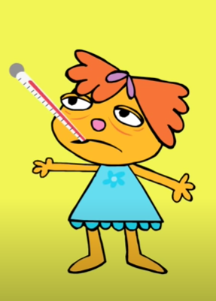
Match the French to the English with a line

I’ve got a headache. J'ai mal à la jambe

I’ve got a sore throat. J'ai mal à la tête

I've got sore shoulders J'ai mal au dos

I’ve got a sore leg. J'ai mal aux dents

I’ve got backache. J'ai mal aux épaules

I’ve got earache. J'ai mal à la gorge

I feel sick (nauseous). J'ai mal aux oreilles

I’ve got toothache. J'ai mal au coeur

Now …...practise telling someone else at home where it hurts. Add some drama! Point to the place that it hurts and show you’re in pain! For example ‘J’ai mal aux oreilles!’ (I have earache!) and touch your ears showing you’re in pain in your facial expression! You could do a role play as if you are at the doctor’s so that when you go to France or a French speaking country you can get help if you don’t feel well!

