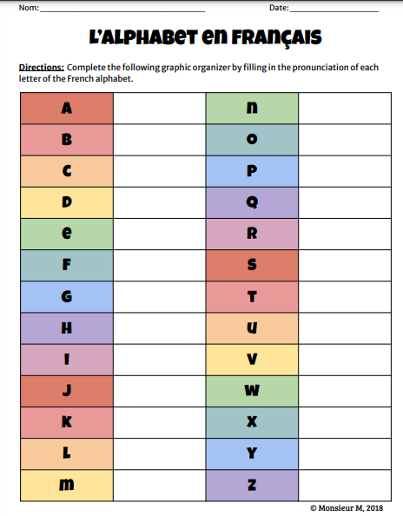
If you cannot print the sheet out then write the pronunciation of each letter below:
A ah L W
B M X
C N Y
D O Z
E P
F Q
G R
H S
I T
J U
K V

