My name is: _______________ Date: 21.1.21
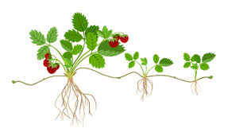
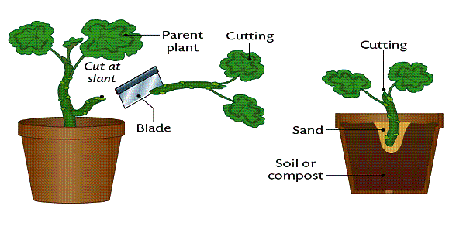
HABITATS - Lesson 3

Asexual reproduction in plants

BIG questions:
How do bulbs, tubers and runners reproduce asexually?
________________________________________________________________________________________________________________________________________________________________________________________________________________________________________________________________________________________________________________________________________

Describe two plants which reproduce in this way. ______________________________________________________________________________________________________________________________________________________________________________________________________________________________________________________

Choose a plant and draw its life cycle – draw a diagram of it (in this box) with labels. Use the example of the fern to help you.

What is vegetative propagation and how does it help plants reproduce asexually?
______________________________________________________________________________________________________________________________________________________________________________________________________________________________________________________

Going deeper…
Why is it advantageous to plants to be able to reproduce asexually?
______________________________________________________________________________________________________________________________________________________________________________________________________________________________________________________

Is there a link between the perfume of a flowering plant and its life cycle? Are plants which reproduce asexually reliant on anything else to reproduce? Birds, insects, animals, the wind? ______________________________________________________________________________________________________________________________________________________________________________________________________________________________________________________

