Scheme of work
ART & DT
Class 4 – AUTUMN 2021

ART: SELF-PORTRAITS: line & tone
Y5: To identify and draw objects and use marks and lines, to produce texture; to know how to organise line, tone, shape and colour to represent figures and forms in movement.

Y6: To know how to successfully use shading to create mood and feeling; to explain why they have chosen specific techniques to create my art.

D&T: Mechanical systems - Cams
Y5&6: To know how to apply their understanding of how to strengthen, stiffen and reinforce more complex structures; to understand and use mechanical systems in their products [for example, gears, pulleys, cams, levers and linkages]
FOCUSSED ARTIST: Georgia O’Keefe
1 | Intro ppoint – about Georgia O’Keefe  http://christineelder.com/wp-content/uploads/2016/11/Georgia-Okeeffe-Lesson-Plan-by-Christine-Elder.pdf
2 | 24.9.21  Georgia O'Keeffe Inspired Chalk Flower Art lesson  This video is about a Georgia O'Keefe Inspired Chalk Flower art lesson. The students will draw with black glue a flower and let it dry. Once it's dry they will blend in chalk pastels. Music by: DJ Earworm http://djearworm.com/  https://youtu.be/7qVNXeCSesY
3 | 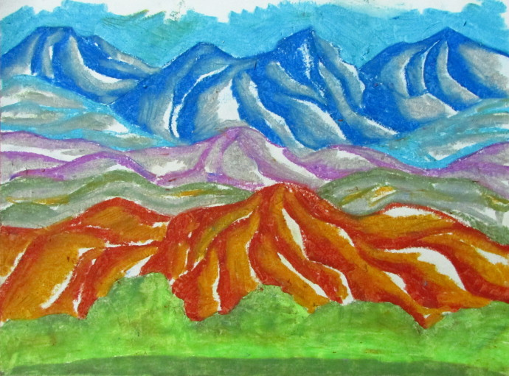  Landscapes in pastel – sketch pads
4 | https://www.youtube.com/watch?v=4zP2AnMjNBY  This step by step tutorial will walk you through drawing and filling in with oil pastel, Georgia O' Keeffe's Painting, Red Poppy, 1927. The supplies are oil pastels, red construction paper, a pencil, and paper towel.
5 | The Lawrence Tree is a painting by Georgia O'Keeffe in 1929 of a large ponderosa pine tree on the D. H. Lawrence Ranch in Taos County, New Mexico. The tree still survives, and may be visited at the Lawrence Ranch.  https://www.youtube.com/watch?v=fZTZxzbQSKQ  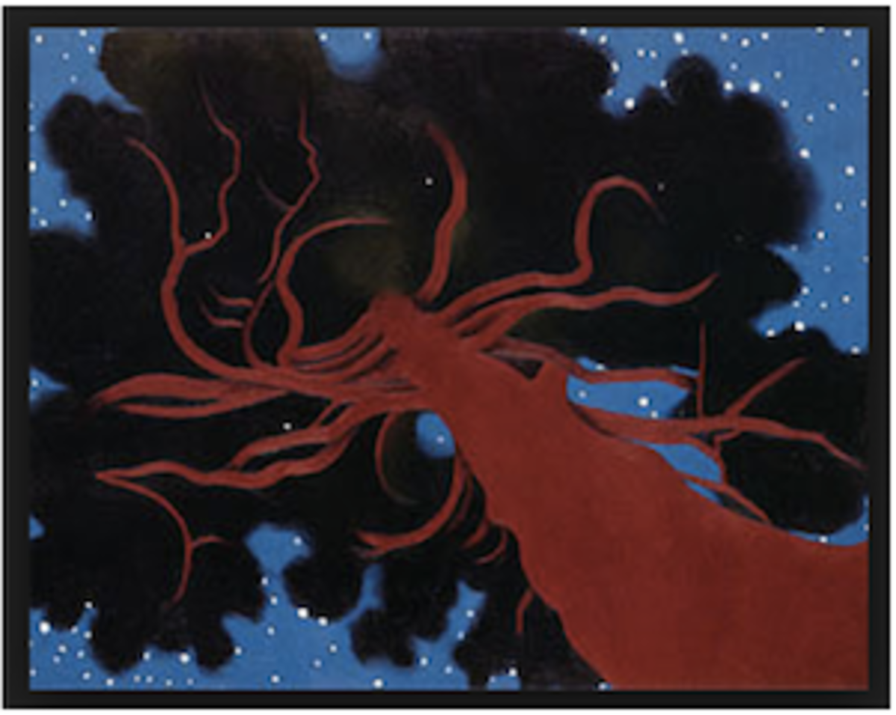
6 | Blue Morning Glories  Created: 1935  

