Cher zoo

Can you match the zoo animal from the story ‘Cher zoo’ to the correct adjective to describe it? Draw a line to match the adjective on the right to the animal on the left. Listen to the story again to remind you of the adjective that describes the animal!

un éléphant 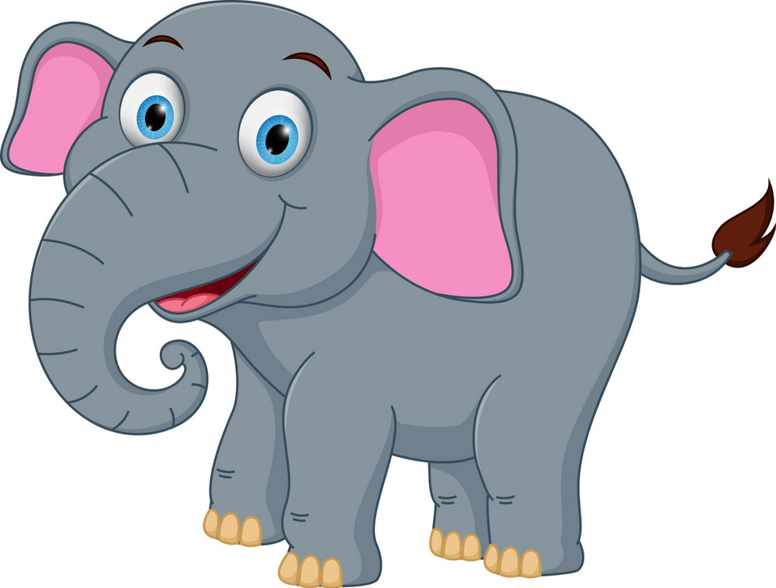 féroce

une girafe 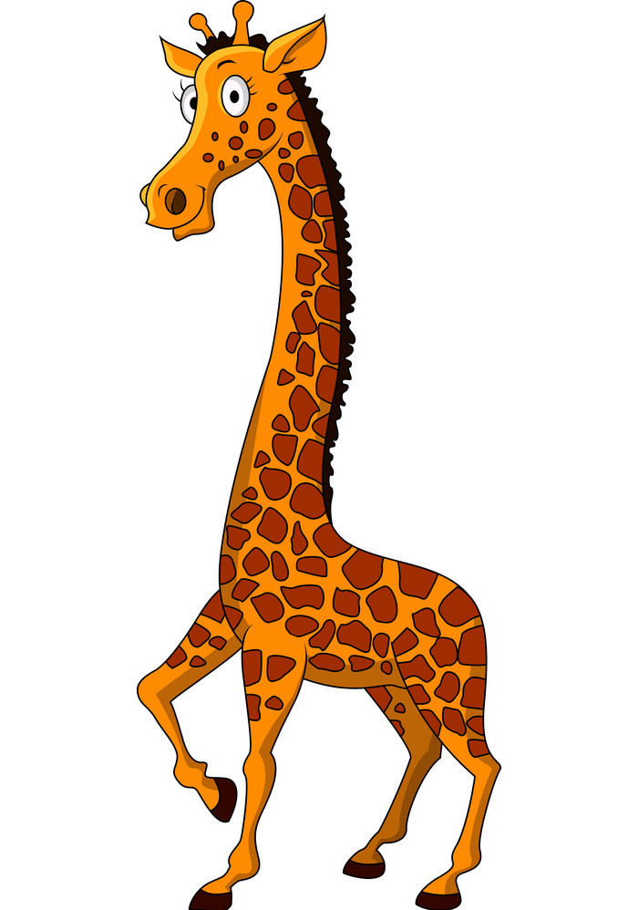 agitée

un lion 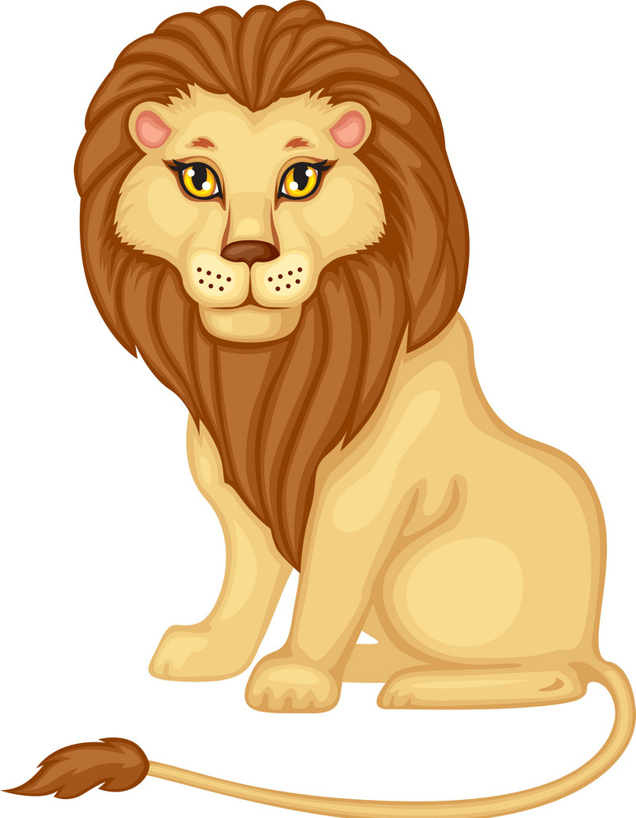 grognon

un dromadaire/ un chameau 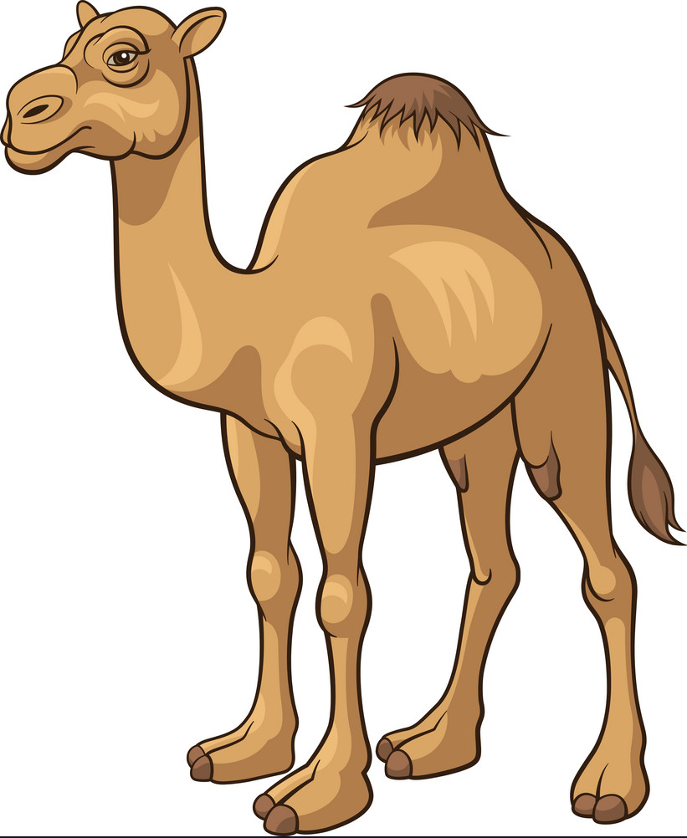 farceur

un serpent 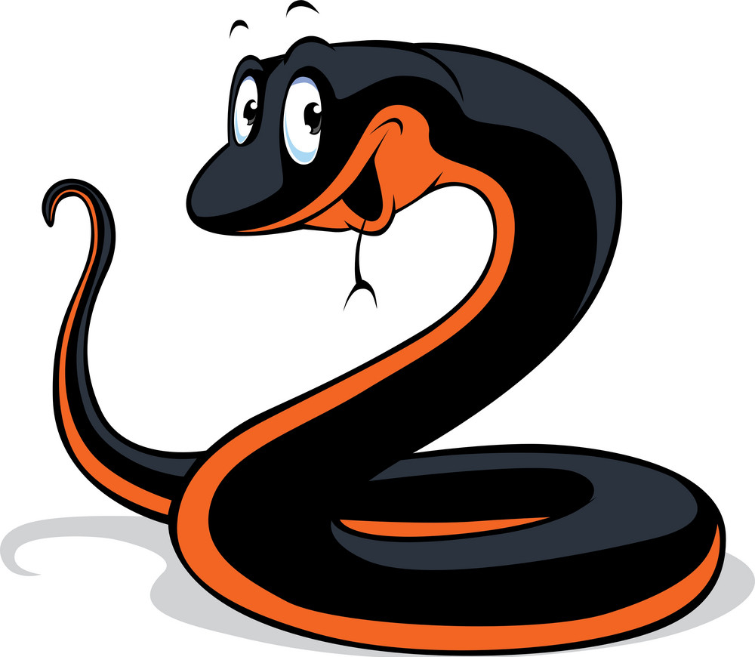 grand

un singe 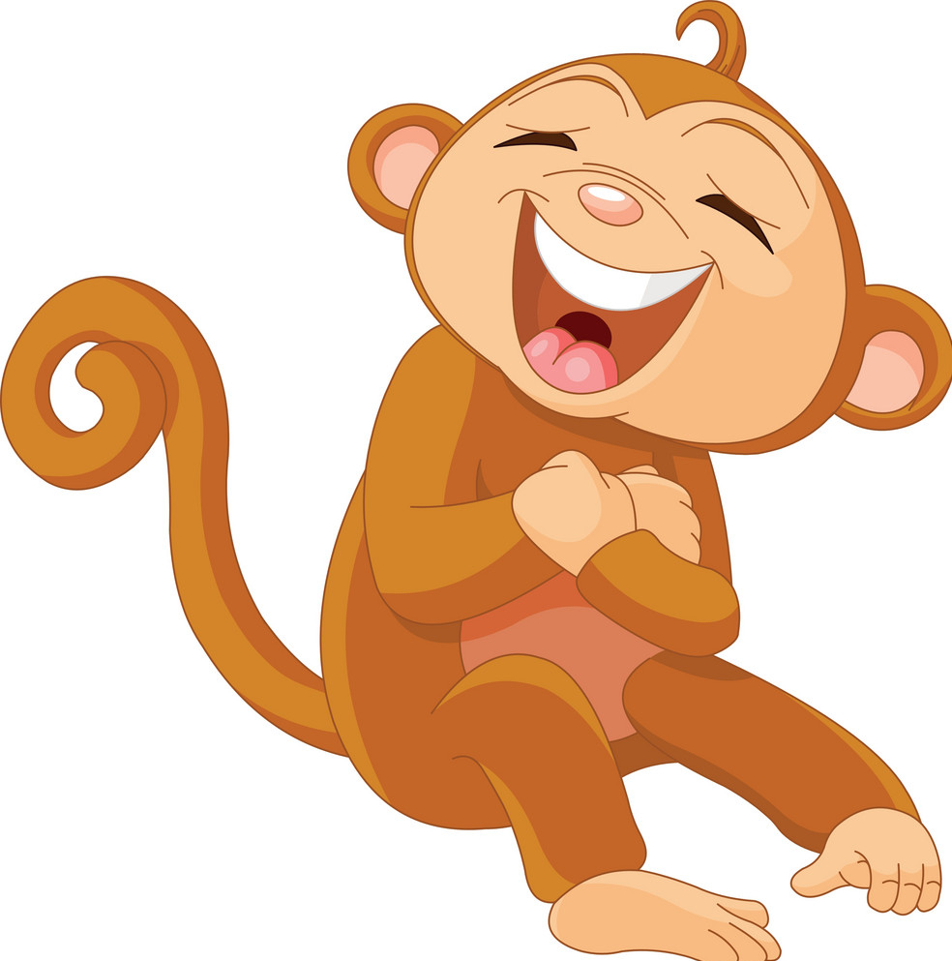 gros

une grenouille 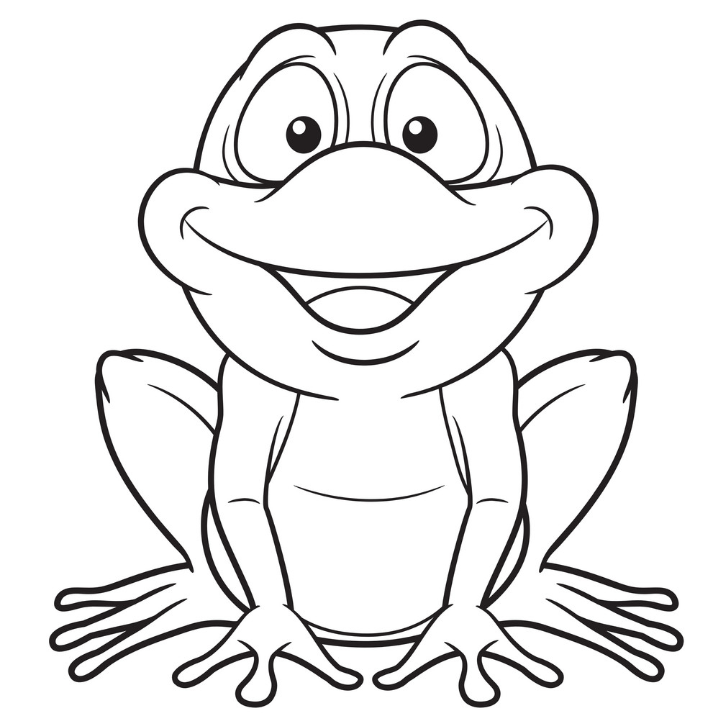 effrayant

un chien 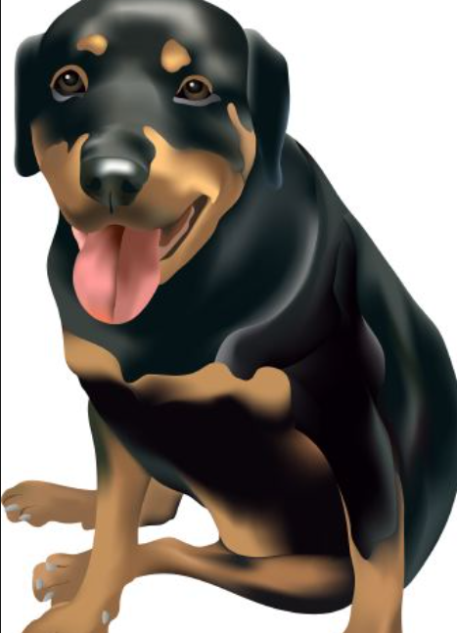 parfait

**TIP!** Nouns are feminine or masculine in French. If a noun is feminine we say ‘une’ for the word a/an that comes before it. If a noun is masculine we say ‘un’ for the word a/an that comes before it. For example un lion and une girafe.

**TIP!** Depending on if it is a un or une word, the adjective might change slightly:

gros grosse

grand grande

grognon grognone

effrayant effrayante

farceur farceuse

agité agitée

parfait parfaite

Examples:

un chien **gros** but une grenouille **grosse**

un serpent **effrayant** but une girafe **effrayante**

* **féroce** stays **the same** for both masculine and feminine nouns that it describes