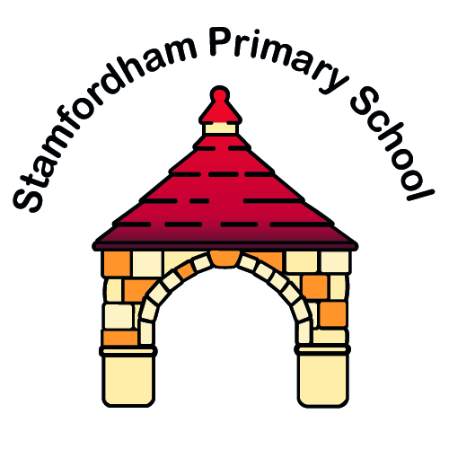
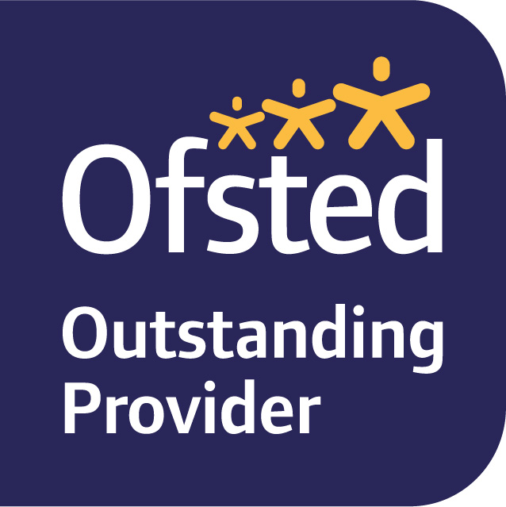
Stamfordham Primary School

Stamfordham, Newcastle upon Tyne, NE18 0NA
Tel: 01661 886358
Head Teacher: Claire McKinney

Email: admin@stamfordham.northumberland.sch.uk
Governing Body email: stamfordhamGB@gmail.com
Website: www.stamfordhamvillageschool.org.uk

@StamfordhamPS

Friday 4th September 2020
Contingency Plan if there are full or partial closures of school or if your child is off school due to quarantine
Dear Stamfordham Families,
The DfE require schools to provide families with access to education if their child is not physically able to be in school. Our school staff are working hard to make some final tweaks to our provision, and we are also looking to provide paper-based work or activity books early next week which will be sent home with your children.
There is a dedicated section of the school website entitled Home School Learning. www.stamfordhamvillageschool.org.uk Please check for updates and resources.
In the meantime, there are helpful links and suggestions listed below:
Early Years
Complete any home learning activities have been set on Tapestry; access the EYFS learning padlet or Oak National Academy remote learning resource for Reception. There are lessons uploaded every weekday. There are some very helpful links below:
https://padlet.com/clairealisonjohnson/ufqivcbbe0ck
https://classroom.thenational.academy/year-groups
https://home.oxfordowl.co.uk
https://www.bloomsburyearlyyears.com/coronavirus-free-access
https://classroomsecrets.co.uk/free-home-learning-packs/#packs
Class 2, 3 and 4
Keep reading. Don’t forget to quiz on any books read if you are able to do so. More e books can be accessed from - https://home.oxfordowl.co.uk
Regularly access Timestable Rockstars.
Access Oak Hall Academy remote learning resource for your child’s year group. There are lessons uploaded each weekday. The DfE have also updated their online education resources for home learning. Some more helpful links below:
https://classroom.thenational.academy/year-groups
https://www.northumberland.gov.uk/Education/Schools/Help-with-homeschooling-Coronavirus-COVID-19.aspx
https://www.gov.uk/government/publications/coronavirus-covid-19-online-education-resources/english-resources#english
https://www.gov.uk/government/publications/coronavirus-covid-19-online-education-resources/list-of-online-maths-resources-for-home-education-during-coronavirus-outbreak#maths
https://www.gov.uk/government/publications/coronavirus-covid-19-online-education-resources/online-science-pe-wellbeing-and-send-resources-for-home-education#science
https://www.gov.uk/government/publications/coronavirus-covid-19-online-education-resources/online-science-pe-wellbeing-and-send-resources-for-home-education#physical-education-pe-and-physical-activity
https://www.gov.uk/government/publications/coronavirus-covid-19-online-education-resources/online-science-pe-wellbeing-and-send-resources-for-home-education#mental-wellbeing
https://www.gov.uk/government/publications/coronavirus-covid-19-online-education-resources/online-science-pe-wellbeing-and-send-resources-for-home-education#special-educational-needs-and-disabilities-send
As always, if you have any questions at all about remote or blended learning, please call us at school. We’re always happy to support you. We are a team and it this together.

With many thanks as always,
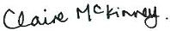
Claire McKinney on behalf of the staff team at SPS

