

How to support your child in Maths in Year 1
The main focus of mathematics teaching in Year 1 is to ensure that pupils develop confidence and mental fluency with whole numbers, counting and place value. This should involve working with numerals, words and the four operations, including with practical resources [for example, concrete objects and measuring tools].

Number and Place value
Children should already be able to:
- count reliably with numbers from 1 to 20, place them in order and say which number is one more or one less than a given number.
New learning:
- Count to and across 100, forwards and backwards, beginning with 0 or 1, or from any given number
- Read and write numbers to 100 in numerals Example of deeper understanding:

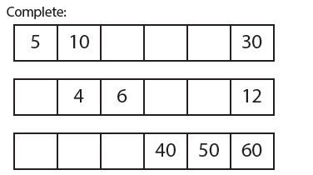

Mental and written calculations

Addition and subtraction
Children should already be able to:
- Number bonds: 5, 6 (addition and subtraction)
- Put the largest number first when adding
- Number bonds: 7, 8 (addition and subtraction) • Number bonds: 9, 10 (addition and subtraction)
- Ten plus ones.
- Doubles up to 10
- Use number bonds of 10 to derive bonds of 11
- add and subtract two single-digit numbers and count on or back to find the answer
- Find the difference between 2 numbers New learning:
- Given a number, identify one more and one less
- Represent and use number bonds and related subtraction facts within 20
- Add 10 and subtract 10
- Teens subtract 10
How we teach it
Addition Subtraction
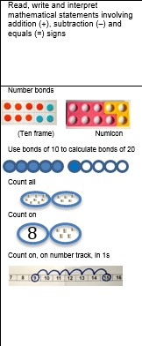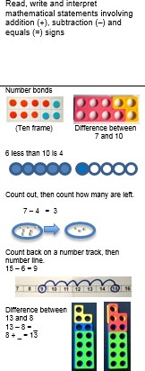

Example of deeper understanding:
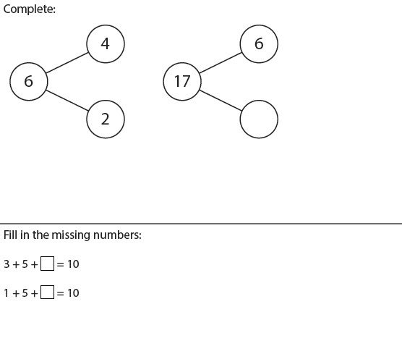

Multiplication and Division
Children should already be able to:
- solve problems, including doubling, halving and sharing.
New learning:
- Count on and back in 2s
- Count on and back in 10s
- Doubles up to 10
- Count on and back in 5s
- Double multiples of 10
- Halves up to 10
- Halve multiples of 10 • How many 2s? 5s? 10s?

How we teach it:
Multiplication Division

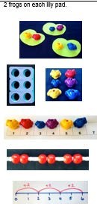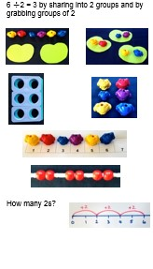

Example of deeper understanding:

