

How to support your child in Maths in Year 2
The main focus of mathematics teaching in Year 2 is to ensure that pupils develop confidence and mental fluency with whole numbers, counting and place value. This should involve working with numerals, words and the four operations, including with practical resources [for example, concrete objects and measuring tools].
By the end of year 2, pupils should know the number bonds to 20 and be precise in using and understanding place value. An emphasis on practice at this early stage will aid fluency.

Number and Place value
Children should already be able to:
- count to and across 100, forwards and backwards, beginning with 0 or 1, or from any given number
- count, read and write numbers to 100 in numerals; count in multiples of twos, fives and tens
- given a number, identify one more and one less
- identify and represent numbers using objects and pictorial representations including the number line, and use the language of:
equal to, more than, less than (fewer), most, least
- read and write numbers from 1 to 20 in numerals and words. New learning:
- Count in tens from any number, forward and backward
- Compare and order numbers from 0 up to 100; use <, > and = signs
- Solve number problems with number facts and place value from the Year 2 curriculum
- Count in steps of 2, 3, and 5 from 0, forward and backward
Example of deeper understanding:

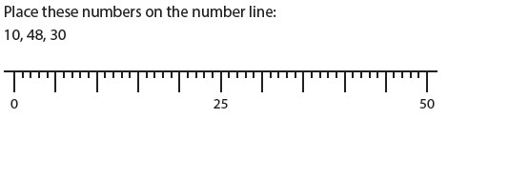

Mental and written calculations

Addition and subtraction
Children should already be able to:
- Find 10 more and 10 less than
- Number bonds: 20, 12, 13 (addition and subtraction)
- Number bonds: 14,15 (addition and subtraction)
- Add 1 digit to 2 digit by bridging.
- Partition second number, add tens then ones
- Add and subtract 10 and multiples of 10.
- Number bonds: 16 and 17 (addition and subtraction)
- Doubles up to 20 and multiples of 5 • Add and subtract near multiples of 10.
- Number bonds: 18, 19 (addition and subtraction)
- Partition and recombine
- Subtract 1 digit from 2 digit by bridging
- Partition second number, count back in 10s then 1s
- Find the difference between two numbers New learning:
- Use addition and subtraction facts to 20
- Recall addition and subtraction facts to 20 fluently, deriving related facts to 100
- Solve problems with addition and subtraction using concrete objects and pictorial representations, including those involving numbers, quantities and measures; applying their increasing knowledge of mental and written methods
- Solve simple problems in a practical context involving addition and subtraction of money of the same unit, including giving change
How we teach it
Addition Subtraction
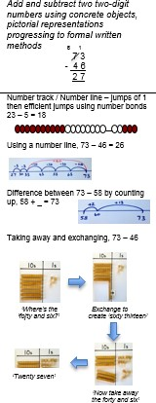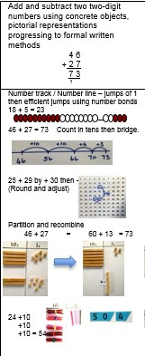
Example of deeper understanding:
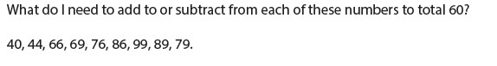

Multiplication and Division
Children should already be able to:
- 2 x table
- 10 x table
- Doubles up to 20 and multiples of 5
- 5 x table
- Count in 3s
- 2 x, 5 x and 10 x tables
- Division facts (2 x table)
- Division facts (10 x table)
- Halves up to 20
- Division facts (5 x table)
- Count back in 3s New learning:
- Recall multiplication and division facts for the 2, 5 and 10 multiplication tables, including recognising odd and even numbers
- Calculate mentally using multiplication and division facts for the 2, 5 and 10 multiplication tables
- Solve problems involving multiplication and division, using materials, arrays, repeated addition, mental methods, and multiplication and division facts, including problems in contexts
How we teach it:
Multiplication Division
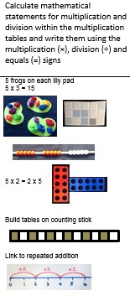
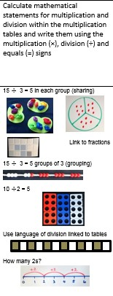

Example of deeper understanding:
