

How to support your child in Maths in Year 3
The main focus of mathematics teaching in Year 3 is to ensure that pupils become increasingly fluent with whole numbers and the four operations, including number facts and the concept of place value. This should ensure that pupils develop efficient written and mental methods and perform calculations accurately with increasingly large whole numbers.
Number and Place value
Children should already be able to:
- count in steps of 2, 3, and 5 from 0, and in tens from any number, forward and backward
- recognise the place value of each digit in a two-digit number (tens, ones)
- identify, represent and estimate numbers using different representations, including the number line
- compare and order numbers from 0 up to 100; use <, > and = signs
- read and write numbers to at least 100 in numerals and in words
- use place value and number facts to solve problems.
New learning:
- Recognise the place value of each digit in a three-digit number (hundreds, tens, ones)
- Find 10 or 100 more or less than a given number
- Count from 0 in multiples of 100
- Count from 0 in multiples of 4, 8 and 50
- Count up and down in tenths; recognise that tenths arise from dividing an object into 10 equal parts and in dividing one-digit numbers or quantities by 10
Example of deeper understanding:

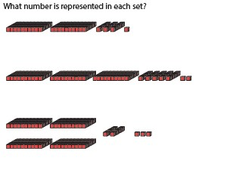

Mental and written calculations
Addition and subtraction
Children should already be able to:
- Add and subtract multiples of 10 and 100
- Add a single digit, bridging through boundaries (e.g. across 10s)
- Partition second number to add
- Know pairs of 100
- Use near doubles to add
- Add near multiples of 10 and 100 by rounding and adjusting
- Partition and recombine
- Subtract a single digit by bridging through boundaries
- Partition second number to subtract
- Find the difference between two numbers
- Subtract near multiples of 10 and 100 by rounding and adjusting
New learning:
- Check addition calculations using subtraction and addition and subtraction calculations using rounding
- Mentally add and subtract numbers including a three-digit number with ones, tens or hundreds
- Add and subtract amounts of money to give change, recording £ and p separately
How we teach it
Addition Subtraction
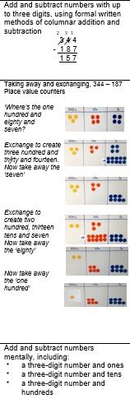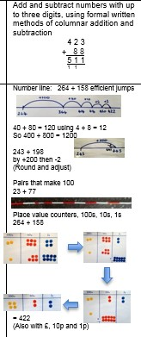
Example of deeper understanding:

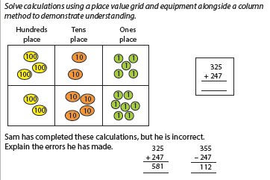

Multiplication and Division
Children should already be able to:
- Know 2x, 5x and 10x and division facts
- 4x table and division facts
- Double two digit numbers
- 8 x table and division facts
- 3 x table and division facts
- Halve two digit numbers New learning:
- Calculate mentally using multiplication and division facts for the 3, 4 and 8 multiplication tables, including two-digit numbers times one- digit numbers
- Recall and use multiplication and division facts for the 3, 4 and 8 multiplication tables
- Write and calculate mathematical statements for multiplication and division using the multiplication tables that they know, including for two-digit numbers times one- digit numbers, using mental and progressing to formal written methods
How we teach it:
Multiplication Division

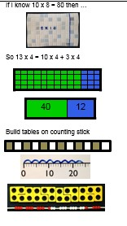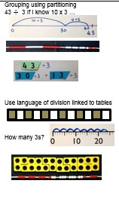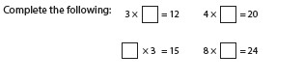

Example of deeper understanding:

