

How to support your child in Maths in Year 4
The main focus of mathematics teaching in Year 4 is to ensure that pupils become increasingly fluent with whole numbers and the four operations, including number facts and the concept of place value. This should ensure that pupils develop efficient written and mental methods and perform calculations accurately with increasingly large whole numbers.
By the end of year 4, pupils should have memorised their multiplication tables up to and including the 12 multiplication table.

Number and Place value
Children should already be able to:
- count from 0 in multiples of 4, 8, 50 and 100; find 10 or 100 more or less than a given number
- recognise the place value of each digit in a three-digit number (hundreds, tens, ones)
- compare and order numbers up to 1000
- read and write numbers up to 1000 in numerals and in words
- solve number problems and practical problems involving these ideas.
New learning:
- Order and compare numbers beyond 1000
- Count to multiples of 1000; count backwards through zero to include negative numbers
- Find 1000 more or less than a given number
- Round whole numbers to 10,000 to the nearest 10, 100 or 1000
- Rounds decimals with one decimal place to the nearest whole number
- Convert from larger to smaller units of metric measure e.g. m to cm
- Count in multiples of 6, 7, 9 and 25
- Count up and down in hundredths; recognise that hundredths arise when dividing an object by one hundred and dividing tenths by ten

Example of deeper understanding:

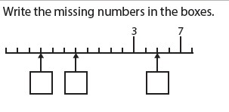

Mental and written calculations

Addition and subtraction
Children should already be able to:
- Add and subtract multiples of 10s , 100s, 1000s
- Be fluent when adding 2 digit + 2 digit
- Partition second number to add
- Know decimal pairs of 10 and 1
- Use near doubles to add
- Adjust both numbers before adding
- Add near multiples
- Partition and recombine
- Be fluent when subtracting 2 digit - 2 digit
- Partition second number to subtract
- Decimal subtraction from 10 or 1
- Find the difference between two numbers
- Subtract near multiples by rounding and adjusting
New learning:
- Solve calculation problems involving two-step addition and subtraction in context, deciding which operations to use and why
- Solve calculation problems involving two-step addition and subtraction in context, deciding which methods to use and why

How we teach it
Addition Subtraction
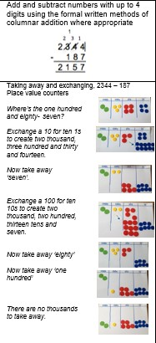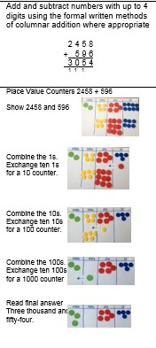
Example of deeper understanding:

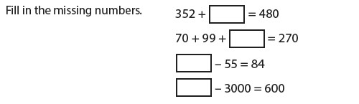

Multiplication and Division
Children should already be able to:
- 4x, 8x tables and division facts
- 10 times bigger
- 3x, 6x and 12x tables and division facts
- Double larger numbers and decimals
- 3x, 9x tables and division facts
- 11x, 7 x tables and division facts
- 6x, 12 x tables and division facts
- 10 times smaller
- Halve larger numbers and decimals New learning:
- Count in multiples of 6, 7,9 and 25
- Multiply two - digit and three - digit numbers by a one - digit number using formal written layout
- Divide two - digit and three - digit numbers by a one - digit number using formal written layout
How we teach it:
Multiplication Division

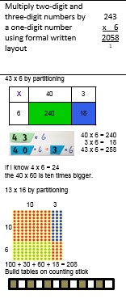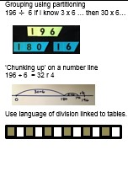

Example of deeper understanding:

