

How to support your child in Maths in Year 5
The main focus of maths teaching in Year 5 is to ensure that pupils extend their understanding of the number system and place value to include larger whole numbers (positive and negative). This should develop the connections that pupils make between multiplication and division with fractions, decimals, percentages and ratio.

Number and Place value
Children should already be able to:
- count in multiples of 6, 7, 9, 25 and 1000
- find 1000 more or less than a given number
- count backwards through zero to include negative numbers
- recognise the place value of each digit in a four-digit number (thousands, hundreds, tens, and ones)
- order and compare numbers beyond 1000
- identify, represent and estimate numbers using different representations
- round any number to the nearest 10, 100 or 1000
- solve number and practical problems that involve all of the above and with increasingly large positive numbers
- read Roman numerals to 100 (I to C) and know that over time, the numeral system changed to include the concept of zero and place value.
New learning:
- Read and write numbers to at least 1 000 000 and determine the value of each digit
- Order and compare numbers to at least 1 000 000
- Read, write, order and compare numbers with up to three decimal places
- Convert between different units of metric measure (e.g. x or ÷ by 10, 100, 1000)
- Count forwards and backwards with positive and negative whole numbers, including through zero
- interpret negative numbers in context
Example of deeper understanding:
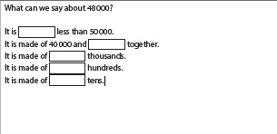

Mental and written calculations

Addition and subtraction
Children should already be able to:
- Add multiples of 10s , 100s, 1000s, tenths,
- Be fluent when adding 2 digit + 2 digit including with decimals
- Partition second number to add
- Use number facts, bridging and place value
- Adjust numbers to add
- Partition and recombine
- Subtract multiples of 10s , 100s, 1000s, tenths,
- Be fluent when subtracting 2 digit - 2 digit including with decimals
- Partition second number to subtract
- Find the difference between 2 numbers
- Adjust numbers to subtract New learning:
- Add and subtract numbers mentally with increasingly large numbers
- Add and subtract whole numbers with more than 4 digits, including using formal written methods (columnar addition and subtraction)
- Solve problems involving addition and subtraction involving numbers up to three decimal places • Add and subtract decimals including those with a different number of decimal places
How we teach it
Addition Subtraction
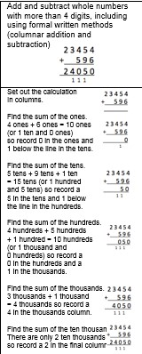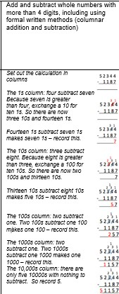
Example of deeper understanding:
Set out and solve these calculations using a column method.
3254 + = 7999
2431 = – 3456
6373 – = 3581
6719 = – 4562

Multiplication and Division
Children should already be able to:
- Know 4x, 8x tables and division facts
- Make a number 100, 1000 times bigger
- Know 3x, 6x and 12x tables and division facts
- Make a number 10, 100, 1000 times smaller
- Double larger numbers and decimals
- Know 9x tables and division facts
- Know 11x , 7 x tables and division facts
- Partition to multiply mentally
- Know 6x, 12 x tables and division facts
- Partition to divide mentally
- Halve larger numbers and decimals
- Partition decimals to divide mentally New learning:
- Identify multiples and factors, including all factor pairs of a number, and common factors of 2 numbers
- Solve calculation problems involving multiplication and division including using their knowledge of factors and multiples, squares and cubes
- Read and write decimal numbers as fractions

How we teach it:
Multiplication Division
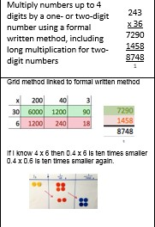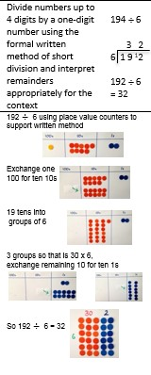

Example of deeper understanding:
