

How to support your child in Maths in Year 6
The main focus of maths teaching in Year 6 is to ensure that pupils extend their understanding of the number system and place value to include larger whole numbers (positive and negative). This should develop the connections that pupils make between multiplication and division with fractions, decimals, percentages and ratio.
By the end of Year 6, pupils should be fluent in written methods for all four operations, including long multiplication and division, and in working with fractions, decimals and percentages.

Number and Place value
Children should already be able to:
- read, write, order and compare numbers to at least 1 000 000 and know the value of each digit
- count forwards or backwards in steps of powers of 10 for any given number up to 1 000 000
- interpret negative numbers in context, count forwards and backwards with positive and negative whole numbers, including through zero
- round any number up to 1 000 000 to the nearest 10, 100, 1000, 10 000 and 100 000 • solve number problems and practical problems that involve all of the above
- read Roman numerals to 1000 (M) and recognise years written in Roman numerals. New learning:
- round whole numbers to 10 000 000 to a required degree of accuracy (e.g. nearest 10, 100, 1000 etc)
- use negative numbers in context
- calculate intervals across zero
Example of deeper understanding:
Think about the number 34 567 800.
Say this number aloud.
Round this number to the nearest million.
What does the digit ‘8’ represent?
What does the digit ‘7’ represent?
Divide this number by 100 and say your answer aloud.
Divide this number by 1000 and say your answer aloud.

Mental and written calculations

Addition and subtraction
Children should already be able to:
- Add and subtract multiples of 10s , 100s, 1000s, tenths, hundredths
- Be fluent when adding and subtracting two 2 digit numbers, including with decimals
- Partition second number to add and subtract
- Use number facts, bridging and place value
- Adjust numbers to add and subtract
- Partition and recombine
- Find the difference between two numbers New learning:
- Check answers to calculations with mixed operations and large numbers, choosing the most appropriate method, including estimation, and determining, in the context of a problem, an appropriate degree of accuracy
- Solve multi- step addition and subtraction problems in less familiar contexts, deciding which operations and methods to use and why
- Perform mental calculations, including with mixed operations and large numbers
How we teach it
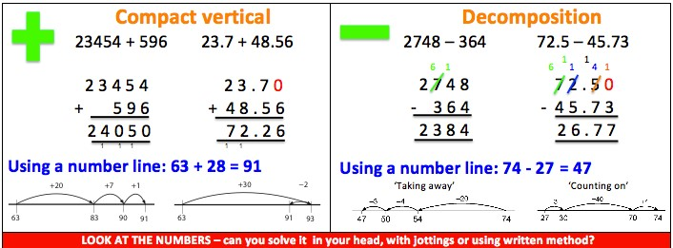
Example of deeper understanding:
Choose digits to go in the empty boxes to make these number sentences true.

14 781 – 6 53 = 8528

23·12 + 22· = 45·23

Multiplication and Division
Children should already be able to:
- Multiplication facts up to 12 x 12
- Partition to multiply mentally
- Double larger numbers and decimals
- Division facts (up to 12 x 12)
- Partition to divide mentally
- Halve larger numbers and decimals New learning:
- Choose the most appropriate method to soclev calculations with mixed operations and large numbers, including in the context of a problem
- Multiply numbers with up to 4 digits by a two-digit whole number using the formal written method of long multiplication
- Divide numbers up to 4 digits by a two-digit whole number using the formal methods of short or long division, and interpret remainders as appropriate for the context as whole numbers, fractions or by rounding
- Use written division methods in cases where the answer has up to two decimal places
- Solve problems involving unequal sharing and grouping using knowledge of fractions and multiples

How we teach it:
Multiplication Division
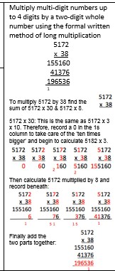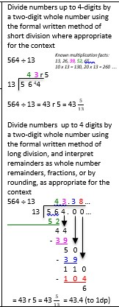

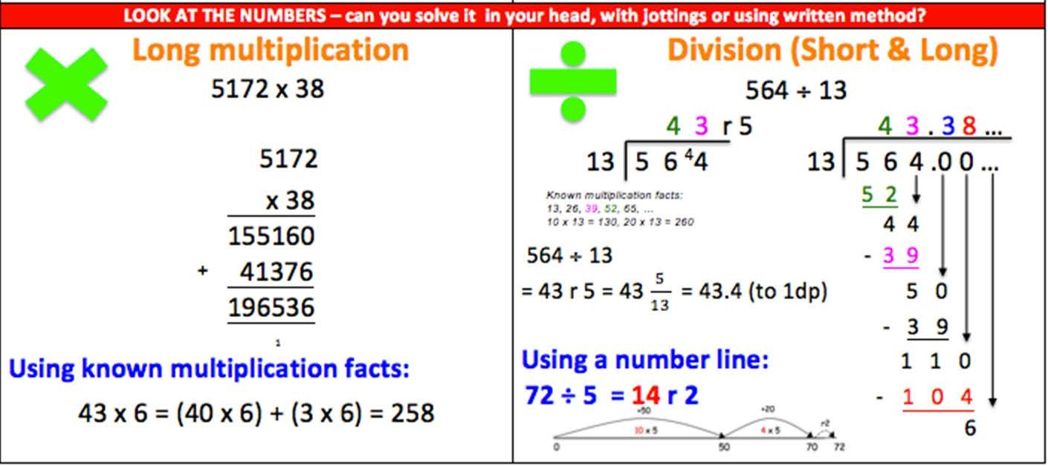
Example of deeper understanding:
Work out:
8·4 × 3 + 8·4 × 7
6·7 × 5 – 0·67 × 50 93 × 0·2 + 0·8 × 93
7·2 × 4 + 3·6 × 8

