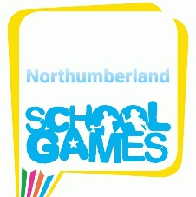

January 8th 2021

Dear School Colleagues, Parents and Guardians,

I wanted to write to tell you about a ‘club’ The Northumberland School Games Organisers have created for school staff and parents/guardians on the exercise app STRAVA. Any person who is employed by a school (Primary or Secondary) or who has a child who attends a school in Northumberland is invited to take part.

The club intends to be a bit of fun to encourage individuals and families to get out and enjoy running/walking and let us see how far we can travel as a collective group over this lock down period!
We have a 'Friendly' challenge with our counterparts from County Durham, Tyne & Wear and Tees Valley who have each set up their own 'Strava' club. We will have an initial ‘warm up’ challenge next week between the county groups starting on Monday 11th January 2021, this will involve ‘who can recruit the most participants/members to their county group’ AND which county group can achieve the most accumulative distance by 10pm on Sunday 17th January 2021.
Then starting on Monday 18th January, the target for each county club is to travel an accumulative distance of 10,000 miles (the distance between the UK and Tokyo- the host city of the 2021 Olympic & Paralympic Games) as quickly as possible – the club to run/walk 10,000miles collectively first are the winners.
This challenge starts on Monday 11th January, though you can opt to join the club at any time from now (we plan on having new challenges to keep motivated throughout this new lockdown period)
The Northumberland School Games Organisers are hoping you might like to join our club and take part in the challenge with us, below is a bit of a guide on how it works.
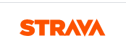
The app is called STRAVA and the app logo looks like this

You will need to download the app (please select the ‘free’ version), sign up (using an email address) and join the ‘Northumberland School Games Lockdown Challenge’ club.
Once you have signed up to STRAVA to join the ‘Northumberland School Games Lockdown Challenge’ club you can either follow this link: https://www.strava.com/clubs/821387 or use the below guidance which shows you how to search a club on your computer.
- Go to the explore tab at the top and scroll down to Clubs
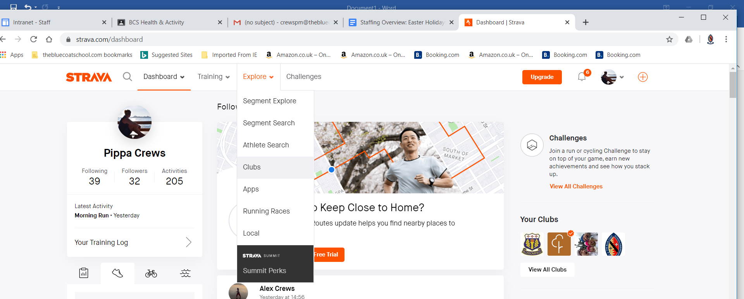
- Type in ‘Northumberland School Games Lockdown Challenge’ Club and press search
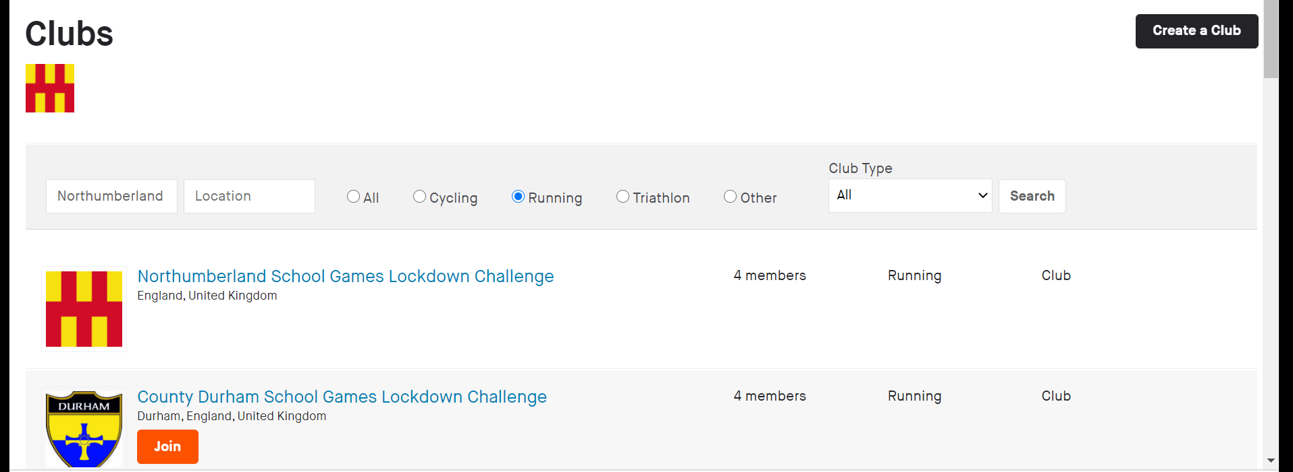

Our club page looks like this
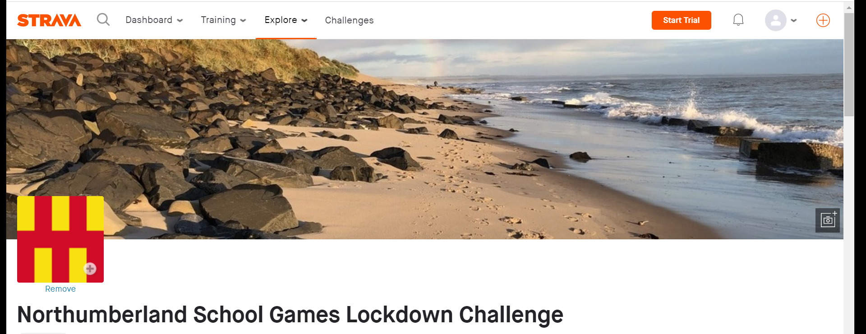

Then if you go for a run or walk track the distance you travel using the app!
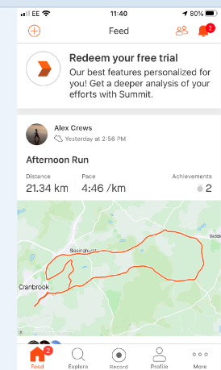
- Press record

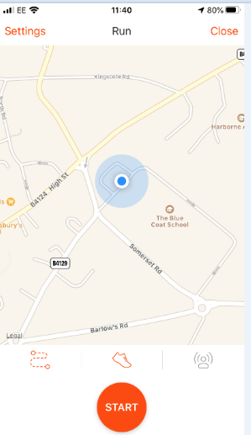
- Choose run (whether you are running or walking) by clicking the picture of a trainer

- Press start (carry the phone with you and it will track your journey
The app will then show us
- A map of your run/walk
- Stats about your run/walk (how far/ how fast etc.)
- It will also collate the data from every person signed up and we will be able to see how far we have run/walked as a collective group!!!!
- It will give updates on how we are getting on with meeting our challenge of travelling 10,000 miles collectively and also let you know how our rivals (the school staff and parents in County Durham, Tyne & Wear and Tees Valley) are doing in comparison!

One very important point to note
- Follow the government’s current advice regarding leaving your home to exercise and mixing with other households.

If you are exercising with your children, please read this additional guidance:
Guidance from The Road Runners Club of America (RRCA) re. how far to run with children:
Children 5 and under should focus on “dash” events that range from a few yards to 400 meters.
Children 5 and over, kids fun runs that are a ½ to 1 mile long may be considered, but allow for a combination of running and walking.
Children ages 12 and over may want to participate in a 5K run.

Please sign up and enjoy exercising!!! Let’s see how far we can go over the lock down period!!!

