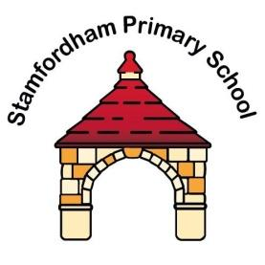

Preschool Admissions Policy

Policy Owner: Lynsey Briddock, Head Teacher
Approver: Stamfordham Primary School Governing Body
Effective date: September 2023
Next Review date: September 2025

Introduction
The school is responsible for admissions to our Preschool. This policy will be used to determine admissions to the Stamfordham Primary School Preschool.
At what age can my child start Preschool?
A child can be considered for a place in Preschool from the age of 2 years.
How do I apply for a place for my child?
If you would like your child to attend Stamfordham Primary School Preschool, application forms are available for collection from the school or via email, admin@stamfordham.northumberland.sch.uk
How are places allocated?
Applications are prioritised on a ‘first come, first served’ basis and compared to the number of places available to determine who will be offered a place.
How will I know if I have a place for my child?
We will contact you by email to offer you a place. If your child is offered a place, you must confirm your acceptance to the school within two weeks of receipt of the offer otherwise the school may have to refuse places for other children unnecessarily. The final decision on when a child is admitted, the number of sessions a child is able to attend and his or her pattern of attendance rests with the Head Teacher.
Applying for a Place in Reception
Reception places are allocated according to the Northumberland County Council’s admission policy as outlined in their Admission Handbook published annually. Admission to our Preschool class does not constitute any right of entry to Reception.

