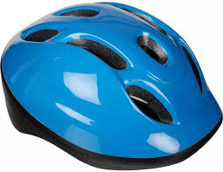Science - Exploring Materials
Making a Bike Helmet
You will need:
- A bike helmet (if you have one)
- An uncooked egg
- Different materials e.g. kitchen roll, cotton wool, cardboard, bubble wrap, scrap of material, newspaper, tinfoil, polystyrene, sellotape or anything you can find that might protect your egg
- A baking tray or large plastic box
- An adult!
What to do
- Look closely at the bike helmet or ask your adult to show you some examples on the internet. When do you need to wear one and why? What is it made from? You will probably see a hard plastic shell, some softer polystyrene inside and some strong straps. Why is the outside made from hard material and the inside quite soft and smooth?
Making a helmet for your egg
- Can you name all the materials you have collected?
- Can you make a helmet for the egg? The egg represents your head!
- Use any of the materials you have collected, remembering that you will probably want softer materials near your egg and stronger, harder materials to protect the egg. It is a good idea to put your egg on the tray or in the plastic box while you do this, in case there are any cracking accidents.
- 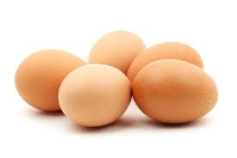When you think your egg is well protected, ask your adult to drop the egg from as high up as they can get. Unwrap your egg to see if it survived. (I recommend dropping the egg outdoors or at least on a very easy to clean floor!)
- Why do you think your helmet was successful/unsuccessful?

