Science Activity – Wednesday 20.1.21

It’s been very cold lately and we’ve had lots

of fun at school smashing ice on the ground,

so this week’s science activity is going to be a

[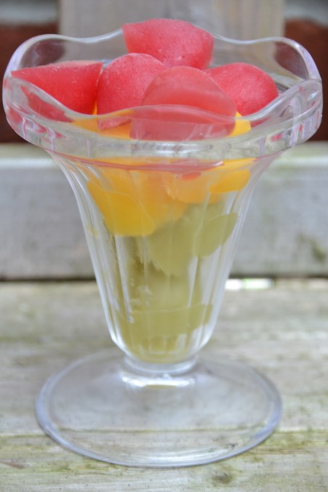](http://www.science-sparks.com/wp-content/uploads/2013/08/DSC_0018.jpg)chilly one!

Have a go at making your own slushy fruit

drink by freezing two or more fruit

juices or squashes, then leaving your ice cubes

out to melt. You could even add in some food

colouring to some to make the colours a bit

more interesting!

* Set up two or three glasses with the same number of ice cubes and place them in different places to see which melts first
* See what colours you can make with different fruit juices
* See if the ice cubes melt faster if you stir them, or hold on to your glass

Top Tips!

Let the juice cubes melt a little before removing them from the ice cube tray. They will feel sticky to start with, because the ice is freezing to moisture in your fingers