**Science – making slime**

What You Need

* An adult

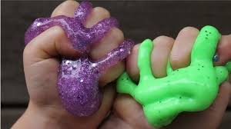

* An apron
* A place to make a mess!
* A large bowl
* 200ml water
* 200-300g cornflour
* Food colouring
* A spoon for stirring

**What To Do**

* Pour the cornflour into the bowl.
* Pour the water in and mix slowly. Keep adding more water until the mixture becomes thick (and hardens when you tap on it).
* Add a few drops of food colouring to make your slime the colour you want it.
* Put your hands in the slime and experiment with handling it.
* What happens when you pick the slime up, squeeze it or even punch it?
* How is it different to water?
* Experiment by adding more cornflour or water and see if you can form a solid ball that then turns into a liquid. Can you roll the ball and bounce it?
* Have fun!