Science – Build a bridge for the Gingerbread Man

Listen to the story - The Gingerbread Man-story
In the story, The Gingerbread Man gets eaten by a fox who offers to help him cross a river. We’re going to help The Gingerbread Man by building him a bridge, testing different materials at the same time. You can bake a Gingerbread Man, make one out of cardboard or use a Play Mobil person or other toy to test your bridge instead.
Method
Build some rests for your bridge (see the pictures below), you could use Lego, cardboard or anything else that works.
Place the material you want to test on the rests and see if your bridge can hold your Gingerbread Man. Keep adding weight until the bridge breaks. Which material was the best for bridge building? Why do you think it worked well? Which was the worst material? Did the design of your bridge make any difference?
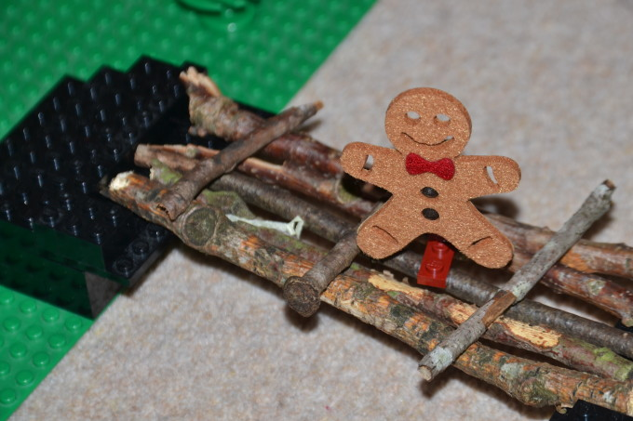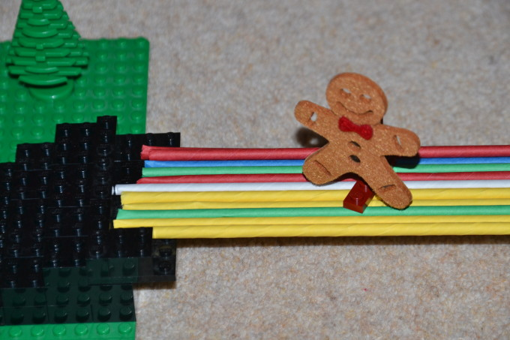Some materials you might use (or choose your own): lolly sticks, straws, cardboard, paper, bubble wrap.

