The Pirates Next Door by Jonny Duddle
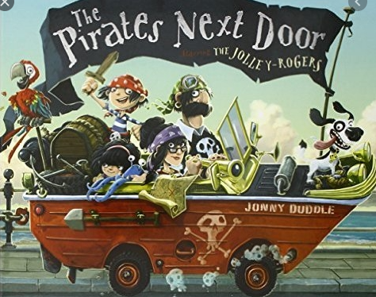

01/02/21 | Literacy Zoom Lesson  Year 1- 9.10-9.40  Year 2- 9.45-10.10  This morning I would like you to listen to the story of ‘The Pirates Next Door’.  Some of you may have read this story before, if not please click on the link below.  Pirates Next Door  After you have listened to the story, I would like you to complete the ‘reasons activity’. Can you think of your own reasons as to why the Pirate should stay and why they should leave?  Capital Letters (The name of your planet needs a capital letter as it is important)  Full Stops  Neat handwriting (Y2 joined)
02/02/21 | Let’s get describing! Today I would like you to look at the picture of the pirate ship on your worksheet. Can you imagine you have just woken up from a really deep sleep and you are on a pirate ship? What can you see? What can you hear? What can you smell? I would like you to write some descriptive sentences to describe the pirate ship using your senses.  You might want to have a go drawing/creating the pirate ship to match your description.  I wonder if you can check your:  Capital Letters  Full Stops  Common exception spellings  Neat handwriting (Y2 joined) You can have a try using joined writing too if you would like Year 1!  Conjunctions e.g. and, so, but. because  Exciting sentence openers instead of ‘It is/it has’
03/02/21 |   Hello Grammar Doctor! Can you look at your pirate ship description and make it better? Have you remembered to talk about all your senses?  Learning to edit our work is so important!  Read your work back to correct any mistakes. Check your capital letters, full stops, handwriting, spellings (common exception words). Can you change some of your vocabulary so it is more exciting?  I wonder if you can check your:  Capital Letters  Full Stops  Spellings (some separated by a comma)  Neat handwriting (Y2 joined)
04/02/21 | Comprehension questions- Please can you complete the comprehension activity found under the literacy star.
05/02/21 | Grammar- Please can you complete the grammar activity found under the literacy star.

