Y1 Comprehension Activity
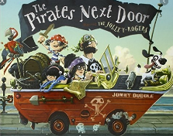

Oooarrr me hearty! Can you have a go answering each question? Remember to write your answers in full sentences.

1) What is the name of the girl? What is her nickname?
e.g The girl is called….. and her nickname is…..
2) How many family members are in the pirate family?

3) What is the pirate mother doing?

4) Why do you think she is doing this?

5) How does Tilda feel about the pirates moving in?

6) Do her family feel the same way? How do you know?

