Y2 Comprehension Activity
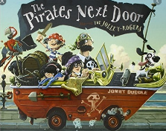

Oooarrr me hearty! Can you have a go answering each question? Remember to write your answers in full sentences.

1) What is the name of the girl? What is her nickname?
e.g The girl is called….. and her nickname is…..

2) Who moves in next door?

3) How many family members are in the pirate family?

4) What is the pirate mother doing?

5) Why do you think she is doing this?

6) How does Tilda feel about the pirates moving in?

7) Do her family feel the same way? How do you know?

8) How do you think the pirates will react to the
neighbours?

9) Have you ever had a friend come round to your
house? How was it similar/different?

10) Can you write 3 pairs of rhyming words from the story?

11) What word on page 21 means the same as ‘start’?

