What is Kevin thinking in each picture?
Can you draw a speech or thought bubble for each picture? You may want to write more than one bubble for each picture.
- We meet Kevin
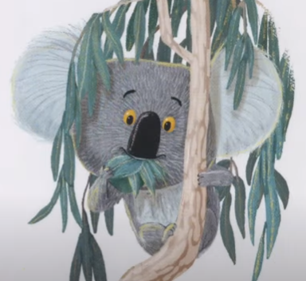
- Kevin see’s the animals below
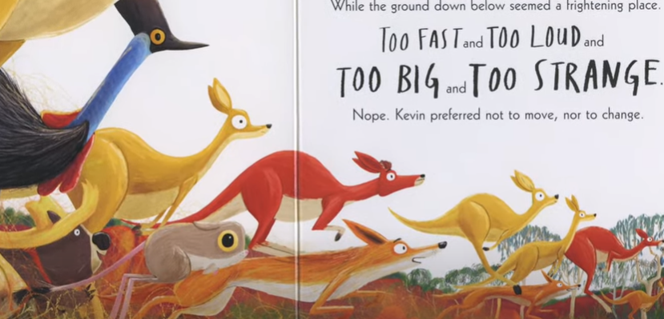
- His friends ask if he wants to play.
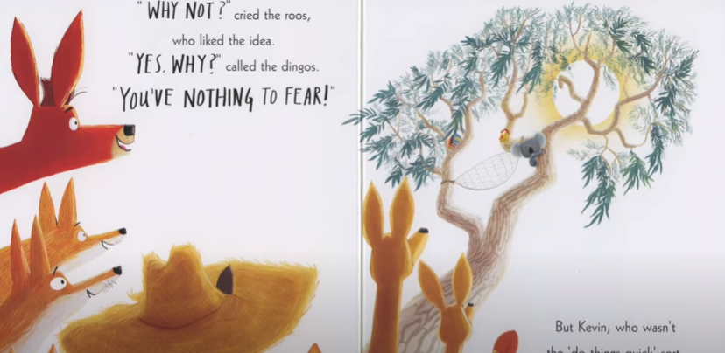
- Kevin thinks about what would happen if he left the tree.
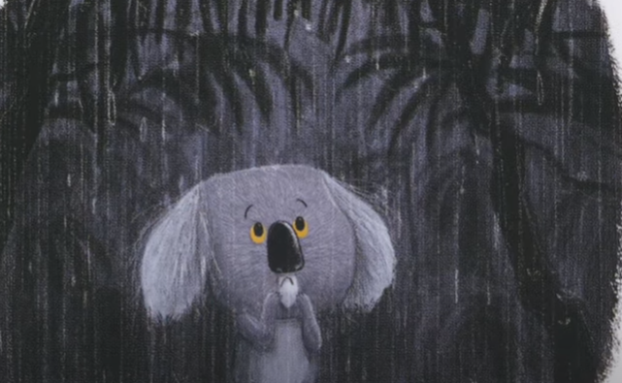

- Kevin’s home is in danger
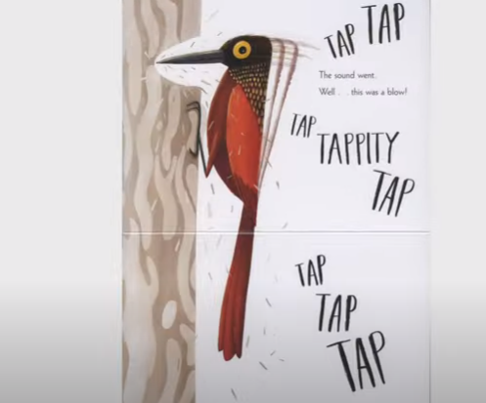

- Kevin won’t let go
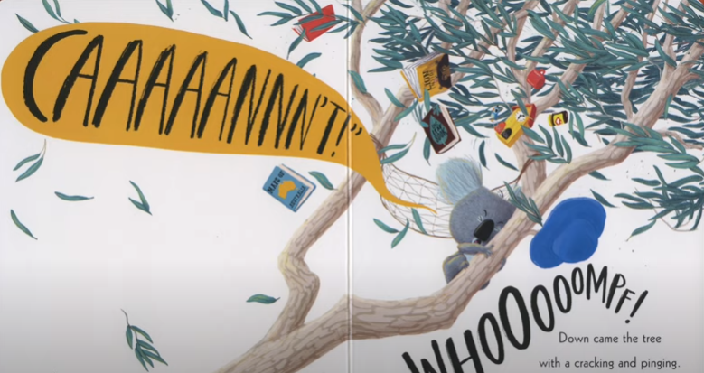

- Kevin plays with his friends on the ground.
