Option 1: Create a 3D Food Chain using animals- Remember to always start with a producer.

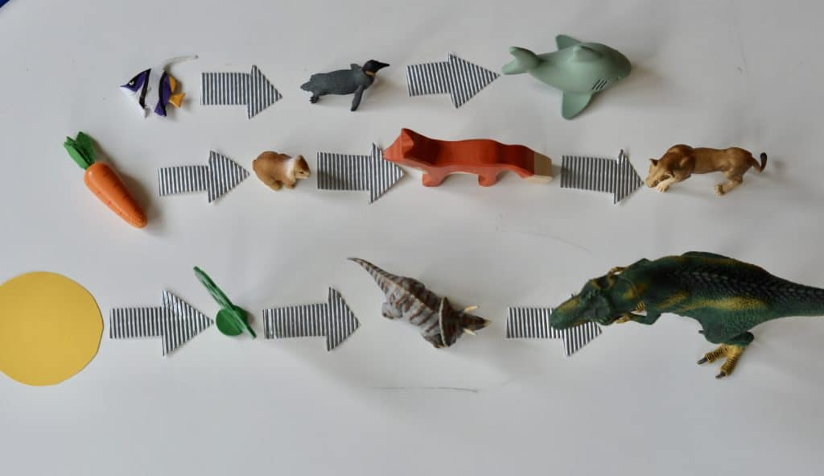

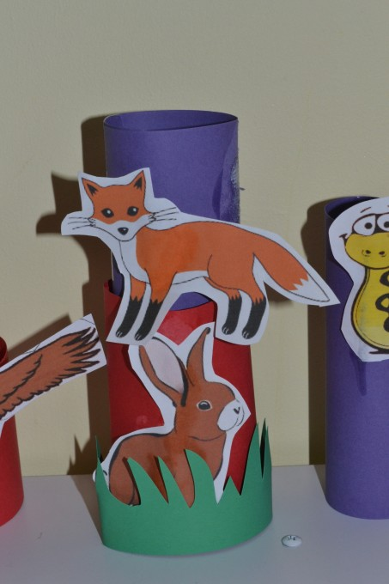
Option 2: Create stacking Food Chains, remember you can draw your animals. The biggest tube needs to be the producer with the tubes getting smaller each time.

Option 3: Create a food chain paper chain (What is the longest food chain you can make?) Can you make more than one and compare?
