The Koala Who Could by Rachel Bright
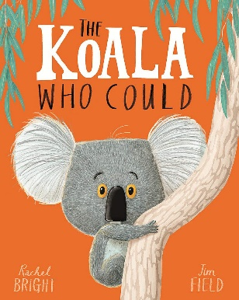
01/03/21 | Literacy Zoom Lesson  Year 1- 9.25-9.50  Year 2- 9.55-10.15    Character Inference: Can you look at the picture on the worksheet and think of some speech/thought bubbles to add to Kevin’s character in the illustrations? What might he be thinking in each picture? You might want to add more than one bubble for each picture as he might have a lot of thoughts. Feel free to cut the pictures out and draw around them on different pieces of paper if it gives you more room to write.  Capital Letters  Exciting vocabulary  Neat handwriting (concentrate on letter sizes)
02/03/21 | Can you write a diary entry from Kevin’s point of view for the day after his tree fell down? How does he feel about what happened? How has his life changed?  I wonder if you can check your:  Capital Letters  Full Stops  Exciting vocabulary  Conjunctions to make your sentences longer and more exciting (because, so, but, and)  Spellings  Neat handwriting (Y2 joined)
03/03/21 |   Grammar Doctor  I wonder if you can check your:  Capital Letters  Full Stops  Spellings  Neat handwriting (Y2 joined)  Year 2 Sentence openers (are your sentences all starting the same way? If so how could you change them?)
04/03/21 | World Book Day:  Reading Challenge Cards- Can you choose 5 challenges from the Reading Challenge cards to complete today and tomorrow?
05/03/21 | Reading Challenge Cards- Can you continue your reading challenge from yesterday or choose a new challenge from the cards for today?

