**Beegu by Alexis Deacon**

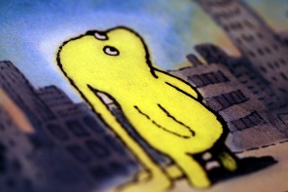

|  |  |
| --- | --- |
| **Literacy**  **Resources:**  PowerPoint/Video of Beegu  Lined Paper/Pen | |
| **06/01/21** | Can you read the story of Beegu on the PowerPoint attached?  Can you look and discuss the images throughout the story? e.g. How was Beegu feeling? Why wasn’t Beegu supposed to be there? How do you know he was feeling that way? What do you think will happen next?  Can you now retell the story of ‘Beegu’ including the information you gathered from the pictures to a family member? |
| **07/01/21** | Look at the picture on slide 3 of the Beegu story. Can you write a few exciting opening sentences for the opening picture of the story? An opening sentence gives us more information about a picture.  *‘A mysterious silver spaceship crashed down to Earth, creating a ginormous crater in the ground.’*  Yr1 - Please remember your capital letters, full stops and finger spaces.  Yr2- Please remember your joined handwriting, capital letters and adjectives.  Remember your letters need to have their bottoms on the line! |
| **08/01/21** | Can you go back and look at the pictures throughout the story. Can you write a descriptive sentence for each picture in the story? (Year 1’s, please choose only 5 or 6 images)  Yr1 - Please remember your capital letters, full stops and finger spaces. Can you include an adjective in each sentence? E.g ‘Beegu stood next to the *old* tree’  Yr2- Please remember your capital letters, full stops, joined handwriting. Can you include two adjectives separated by a comma in each caption? E.g ‘Gloomy Beegu stood next to the old, bare tree’  Remember your letters need to have their bottoms on the line! |