Character Profile
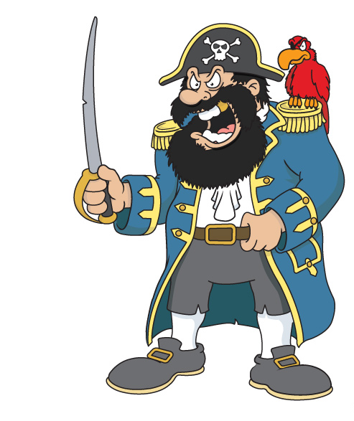
Name: Captain Crunch

Appearance:
_______________________________
_______________________________
_______________________________
________________________________________________________________________________________________________________________________________________________________________________________________________________________________

Personality:
________________________________________________________________________________________________________________________________________________________________________________________________________________________________________________________________________________________

What does he like to do? ________________________________________________________________________________________________________________________________________________________________________________________________________________________________

