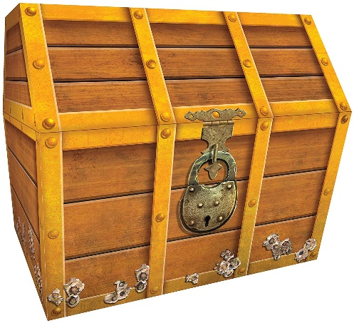
All the Pirates jumped with excitement when they saw the treasure chest. They had been digging for days to find the chest but now the treasure was theirs. Captain Crunch stepped forward to open the chest and the Pirates all squealed with anticipation….
__________________________________________________________________________________________________________________________________________________________________________________________________________________________________________________________________________________________________________________________________________________________________________________________________________________________________________________________________________________________________________________________________________________________________________________________________________________________________________________________________________________________________________________________________________________________________________________________________________________________________________

