The Pirates Next Door by Jonny Duddle
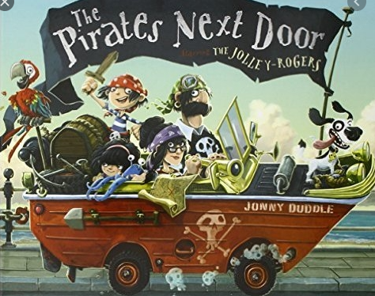

08/02/21 | 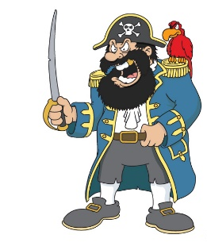  Literacy Zoom Lesson  Year 1- 9.25-9.50  Year 2- 9.55-10.15  Good morning, meet Captain Crunch on your worksheet. He is the Captain of a very important pirate ship.  Can you complete the character profile of Captain Crunch. You need to describe his personality (how he behaves?) and his appearance (what he looks like?). We are going to use Captain Crunch later on in the week.  Capital Letters (The name of your planet needs a capital letter as it is important)  Full Stops  Exciting vocabulary  Neat handwriting (Y2 joined)  Remember your CONJUNCTIONS to make your sentences longer e.g. ‘and’, ‘because’, ‘but’ ‘so’
09/02/21 |   Hello Grammar Doctor! Can you look at your character profile and make it better?  Learning to edit our work is so important!  Read your work back to correct any mistakes. Check your capital letters, full stops, handwriting, spellings (common exception words). Can you change some of your vocabulary so it is more exciting? Is there anything you have missed?  I wonder if you can check your:  Capital Letters  Full Stops  Spellings (some separated by a comma)  Neat handwriting (Y2 joined)
10/02/21 | 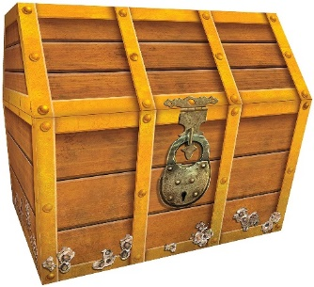  All the Pirates jumped with excitement when they saw the treasure chest. They had been digging for days to find the chest but now the treasure was theirs. Captain Crunch stepped forward to open the chest and the Pirates all squealed with anticipation….  Can you finish the story? Every story needs a problem, what’s the problem going to be and how will Captain Crunch and his crew fix it?
11/02/21 | Hello Grammar Doctor! Can you read your story back with a fresh pair of eyes? Do you like your story, is there anything you would like to change? Can you become a thesaurus thinker and change some of that vocabulary to make it more exciting?  Learning to edit our work is so important!  Read your work back to correct any mistakes. Check your capital letters, full stops, handwriting, spellings (common exception words).  I wonder if you can check your:  Capital Letters  Full Stops  Spellings (some separated by a comma)  Neat handwriting (Y2 joined)
12/02/21 | Grammar- Please can you complete the grammar activity found under the literacy star.

