English
WB 20/09/21

Monday
Can you create your own story map of Jim and the Beanstalk? Watch the story on YouTube if you need reminding
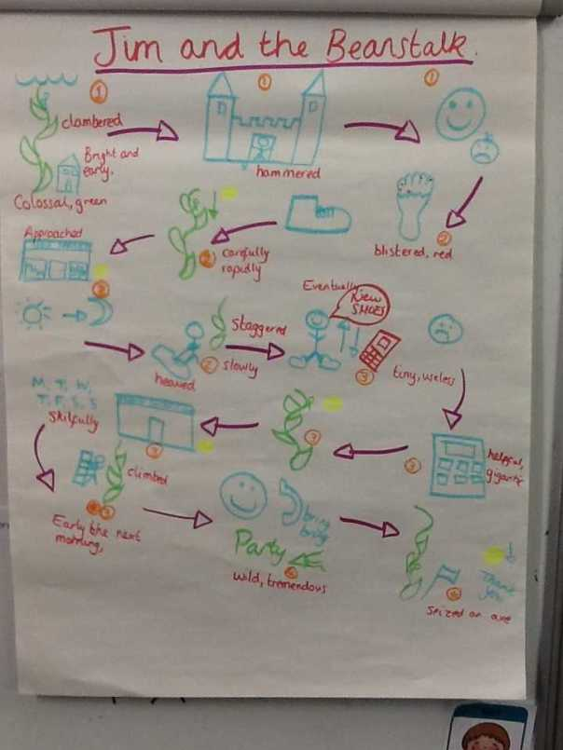
https://www.youtube.com/watch?v=dMaMNpod3Es

Tuesday
What would happen if one thing in the story changed? Change Jim to Jess and create new story map changing the events e.g glasses changes to walking stick, teeth changes to hearing aid and wig changes to jumper)

Wednesday
Children to continue part of the story (worksheet) in their own words verbally with partner and then written in books (Year 1’s to consistently use Full Stop and Capital Letters) (Year 2’s to use sentence openers ‘one morning, after that, the next day etc)

Thursday
Grammar Doctor Day- Children to read back their work from yesterday and finish if not yet finished. Become a Grammar Doctor and make your work better.
Can you check:
Capital letters and full stops.
Have you added in some conjunctions ‘and’, ‘because’, ‘but’?
Have you added in adjectives to make your sentences more exciting?
Check your spelling. Have you used the right sounds/missed any sounds out? Have you spelt your common exceptions words correctly?

Friday
Spelling test: Choose 10 words from the common exception list at the back of your diary and see how many you can tick by correctly spelling.
Grammar activity

