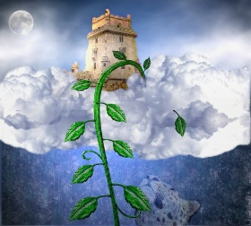
Jess ran to the castle and knocked on the door. She waited and waited until the very old giant opened the heavy door. “Come in, girl, you’re quite safe” said the Giant. Sorry it took me such a long time to open the door, I walk so slowly nowadays so it takes me ages. “Why don’t you get a walking stick to help you?” asked the girl. The Giant gave Jess a gold coin…..”

Jess climbed down the beanstalk and…… _________________________________________________________________________________________________________________________________________________________________________________________________________________________________________________________________________________________________________________________________________________________________________________________________________________________________________________________________________________________________________________________________________________________________________________________________________________________________________________________________________________________________________________________________________________________________________________________________________________________________________________________________________________________________________________________________________________________________________________________________________________________________________

