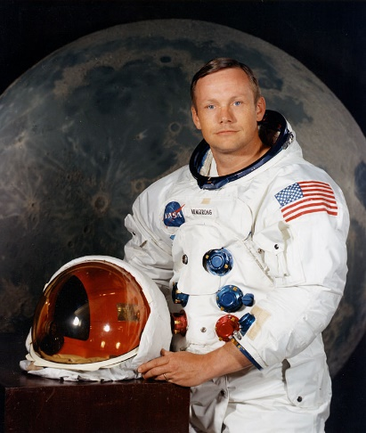

You might want to watch NASA videos from outer space as they may be able to answer some of your questions.