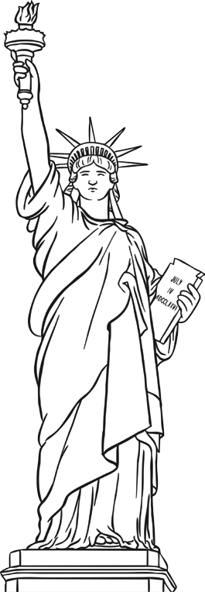
An Amazing Fact a Day
A Statue for School
Amazing Fact
The largest ever Christmas gift was the Statue of Liberty, which was given to the USA by France for Christmas in 1886!
Challenge
Imagine you have been asked to design a statue for your school. Think about where it might go, and what is important in your school. Design a statue that will represent something about your school.
You could also try to find out:
- How the Statue of Liberty was brought from France to the USA?
- What the Statue of Liberty symbolizes?
- How big it is?
- How and why the colour has changed?

