The Koala Who Could by Rachel Bright
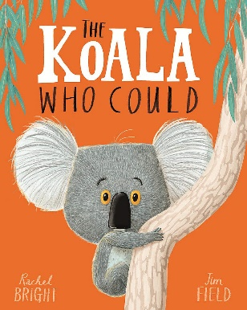
TTD
23/02/21 |   Literacy Zoom Lesson  Year 1- 9.25-9.50  Year 2- 9.55-10.15  How does the author describe Kevin’s habitat?  Can you think of another animal of your choice and write a description of their habitat?  Capital letters and full stops  Exciting vocabulary  Neat handwriting (Y2 joined)  Remember your CONJUNCTIONS to make your sentences longer e.g. ‘and’, ‘because’, ‘but’ ‘so’
24/02/21 |   Can you edit your description from yesterday?  I wonder if you can check your:  Capital Letters  Full Stops  Spellings  Neat handwriting  Have you started your sentences the same way? If so I wonder if you can change your sentence openers? (Year 2).  Challenge: Can you add another few sentences explaining why your animal lives in this habitat and why it might not survive if it moved into a different habitat.
25/02/21 | On a computer/laptop/phone can you record a video review of this book?    If you are unable to record, that is absolutely fine- I wonder if you can talk about it with an adult?  - What happened in the story?  - What do you like / dislike about it?  - Did the story make you think about something that changed in your life?  - What is a can-do attitude?
26/02/21 | Grammar- Please can you complete the grammar activity found under the literacy star.

