1. Complete the table with the past verbs and present verbs with the suffix -ing.

**Change the Tense**

I can change verbs to past tense verbs. I can change verbs to present tense verbs.

|  |  |
| --- | --- |
| **Past** | **Present** |
| played | playing |
|  | talking |
|  | swimming |
| saw |  |
| drank |  |

1. Change the tense of the sentences below. The first one has been done for you.
   1. John watched the football on TV.

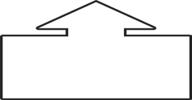

watch

* 1. He is a cold glass of milk.

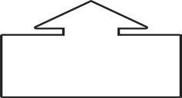

drink

* 1. Layla to school this morning.

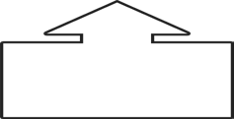

walk

1. Complete the table with the past and present words.

**Change the Tense**

I can change verbs to past tense verbs. I can change verbs to present tense verbs.

|  |  |  |  |
| --- | --- | --- | --- |
| **Past** | **Present** | | |
| played | play | plays | playing |
|  | talk |  |  |
|  | swim |  | swimming |
| saw |  |  |  |
| drank |  |  |  |

1. Can you choose a word from the box and write it into a sentence using the correct tense?