
Class 2

Home Learning Activities- 22/11/21

Please click on the following link which will direct you to our class page: https://stamfordham-primary-school.secure-primarysite.net/home-learning/

Day | 9.00-9.30 | AM ACTIVITES (Remember to take breaks)  10-12am |  | PM ACTIVTIES (Remember to take breaks)  1.30-3pm
 | Active  Time | Literacy  Hibernation Hotel | Maths  Year 1- Numbers to 20  Year 2- Money | Other Subjects  History – WW2  Science- Seasons | Word Time/  Handwriting
Monday | Quiet reading | Can you read up to page 18 in our class story ‘Hibernation Hotel’  What do you predict Bear will do next?  What do you predict the animals will do next? | Year 1- https://classroom.thenational.academy/lessons/to-count-from-1-to-19-and-match-pictorial-and-abstract-representations-of-these-numbers-chgkjt  Year 2- https://classroom.thenational.academy/lessons/to-identify-the-physical-properties-of-coins-ccrp2c | PHSCE  Keeping clean and safe  Can you write a list of items that keep you safe e.g sun cream and a list of items that keep you clean e.g toothbrush | Year 1-  Please can you write 5 words with the ‘ar’ sound in e.g ‘start’, ‘cart’.  Can you write a sentence to include one of your words, remember your Capital letter, finger spaces and full stops!  Year 2-  Please can you write 5 common exception words from your list.  Can you write a few sentences to include some of the words you have practiced? Can you make your sentences longer by using a conjunction and/because/so/but
Tuesday | Please choose any activity on our ‘Active star’ on the class page | Can you complete the VIPERS comprehension challenge? | Year 1- https://classroom.thenational.academy/lessons/to-identify-numbers-to-20-by-counting-ten-and-then-counting-on-6wtkgc  Year 2- https://classroom.thenational.academy/lessons/to-recognise-the-value-of-different-coins-part-1-c8t32e | 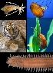  Science  https://classroom.thenational.academy/lessons/what-is-hibernation-6gr3ed | Handwriting  Can you practice your joins from ‘a’ to ‘w’?  Can you practice writing the following words: saw, paw, dawn, claw
Wednesday | Quiet reading | What is a verb? What happens to the verb if we add ‘ing’ suffix on?  Complete the activity 6f in the Hibernation Hotel Resources. | Year 1- https://classroom.thenational.academy/lessons/to-position-numbers-to-20-on-a-number-line-6mw6ac  Year 2- https://classroom.thenational.academy/lessons/to-recognise-the-value-of-different-coins-part-2-6mt68t |   ART  Can you look at secondary colour wheel- can you create your own colour bugs where each wing is a primary colour and the body is the secondary colour.  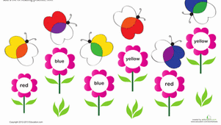  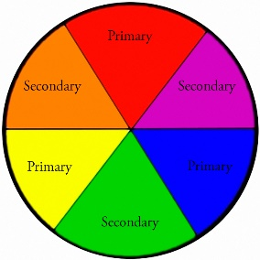 | Year 1-  Please can you write 5 words with the ‘or’ sound in e.g ‘born’ ‘north’.  Can you write a sentence to include one of your words, remember your Capital letter, finger spaces and full stops!  Year 2-  Please can you write 5 common exception words from your list.  Can you write a few sentences to include some of the words you have practiced? Can you make your sentences longer by using a conjunction and/because/so/but
Thursday | Please choose any activity on our ‘Active star’ on the class page | We use the suffix ‘ed’ to tell us the verb happened in the past tense?  Complete activity 7d and 8a in Hibernation Hotel resources  Can you write you own sentences with some of the words found in activity 8a? | Year 1- https://classroom.thenational.academy/lessons/to-identify-one-more-and-one-less-than-a-number-within-20-ccvkae  Year 2- https://classroom.thenational.academy/lessons/to-recognise-the-value-of-different-coins-and-notes-65j64e |   History-  Can you create your own identity card for WW2 as an evacuee? | Handwriting  Can you practice writing the following sentence with your joined handwriting:  ‘I saw a tiny paw’  ‘The black dog had a sharp claw on his paw’
Friday | Joe Wickes recorded workouts (You Tube) | Spelling test: Choose 10 words from the common exception list at the back of your diary and see how many you can tick by correctly spelling. | Year 1- ‘Hit the button’  Number bonds to 10  https://www.topmarks.co.uk/maths-games/hit-the-button  Year 2- ‘Hit the button’ addition and subtraction within 10  https://www.topmarks.co.uk/maths-games/hit-the-button | Music Can you create your own dance moves to ‘Goodbye Tipperary’? | Can you build a den and read a story inside?

PLEASE KEEP READING AT HOME- SUPER IMPORTANT

