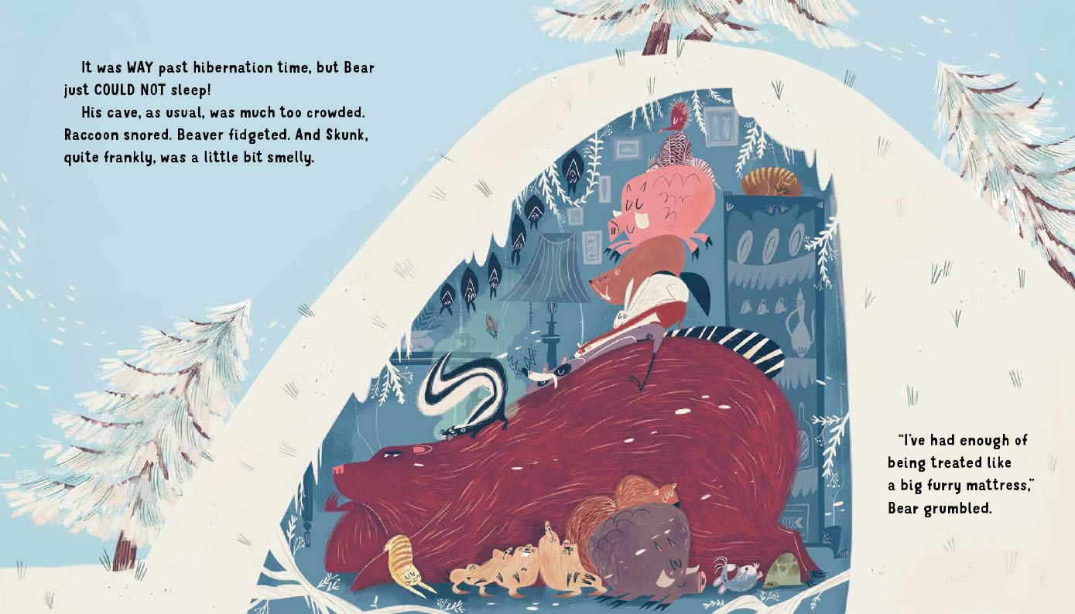
What is ‘hibernation’?
________________________________________________________________________________________________________________
Why can’t Bear sleep? ________________________________________________________________________________________________________________
What was Beaver doing? ________________________________________________________________________________________________________________

Find a word that is similar in meaning to ‘complained’
________________________________________________________

What does Bear mean when he says he is being treated like a furry mattress? ________________________________________________________________________________________________________________________________________________________________________

