
Here are some activities to explore the theme ‘Spread a little kindness’

Activity 1
How can we be kind to others?
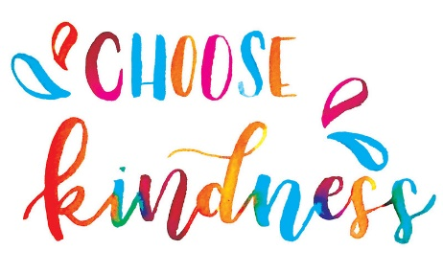
Write these ideas down on paper.
For example
- Use manners
- Share
- Respect
- Say please and thank you

Activity 2
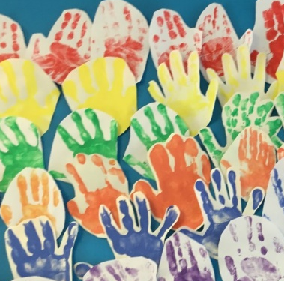
- Choose a colour of paint to paint your hand.
- Carefully dip a brush into the paint and paint it onto your hand
- Press your hand down onto some paper.
- Make sure you wash your hands and wash all the paint off.
- When the paint is dry write a positive word from activity one on the palm of the hand.

If you do not have access to paint, you could draw around your hands, decorate them and cut them out.
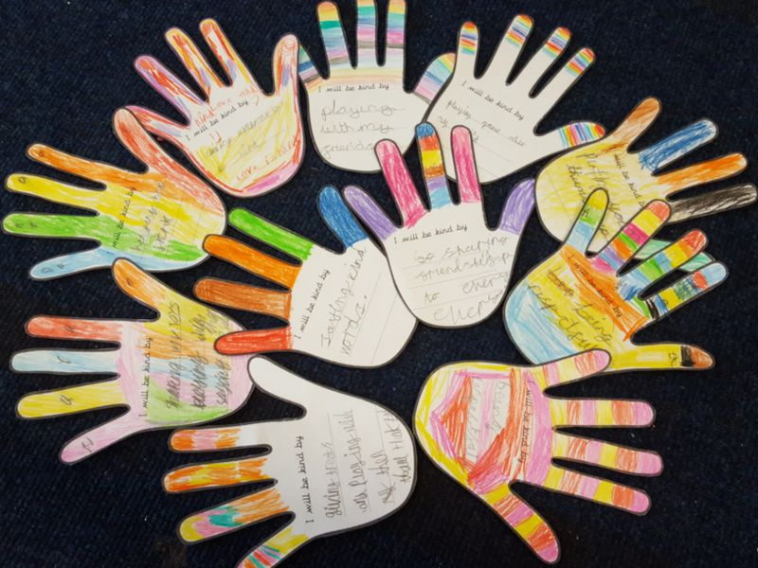
You might want to create more than one and display in a heart shape like the one below. You could display this in your window or somewhere in your house.
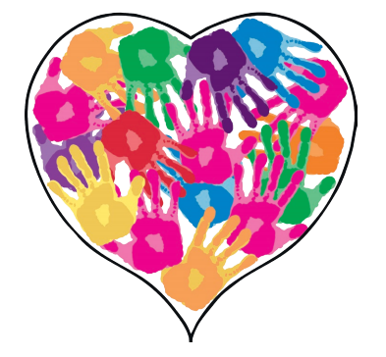

Here is an activity to explore the theme ‘Being Ourselves’
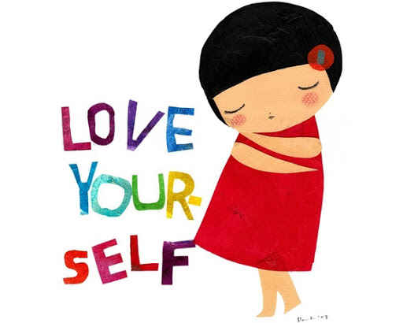

Activity
How can you be kind to yourself?
We often think about how we can be kind to others and what effect our behaviour has on other people.
Have you ever thought about how you can be kind to yourself?
Draw hearts of different sizes on a piece of paper and write inside the hearts how you can be kind to yourself. Here is an example below.

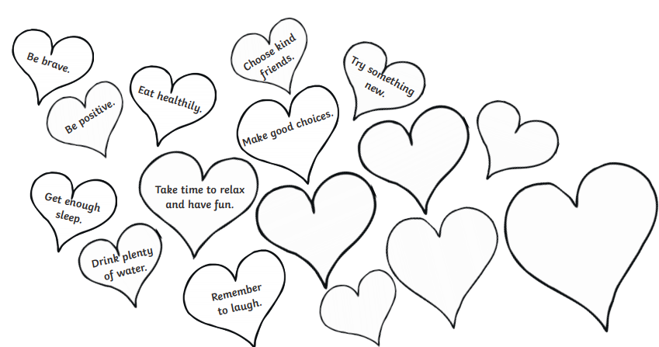

Here is an activity to explore the theme ‘Healthy inside and out’
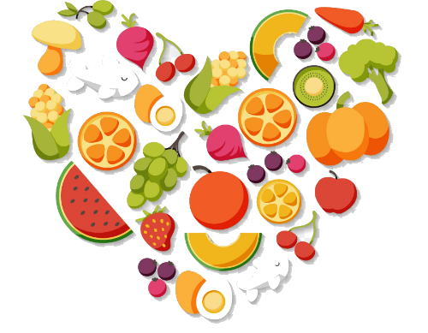

Connecting through food

Food helps us feel happy and healthy in our minds as well as our bodies.

For this activity you will need a piece of paper and some pens.
- On a piece of paper, draw two circles.
- In the first circle, draw how you feel when you are really hungry and in the second circle, ask draw how you feel when you’ve had a big tasty meal.
- Talk about how each circle makes you feel and what your face would look like. What was different about the faces? Why?

How I feel when I have eaten a tasty meal
How I feel when I am hungry


Eating healthy food together helps wellbeing and brings us together. You may want to have a healthy snack, stop to eat, drink and talk. What do you like about this time together and why?

