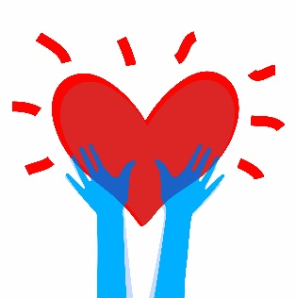
Here are some activities to explore the theme ‘Spread a little kindness’
Activity 1
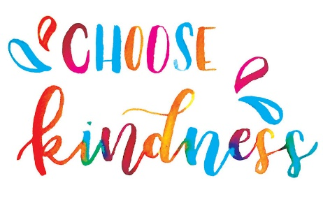
Think of a time someone was kind to you. Write about this time and draw pictures to celebrate this.
Think about…
- What happened?
- What did they do?
- What did it make you think?
- How did it make you feel?

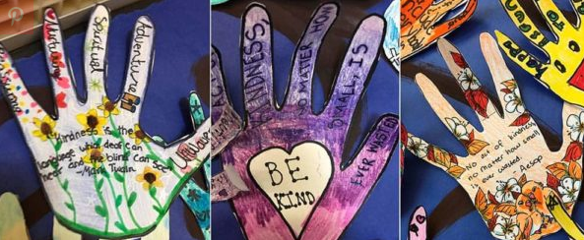
Activity 2
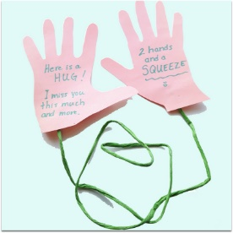
Draw an outline of your hand on a piece of paper. On each finger, write or draw an idea of how to be kind to other people
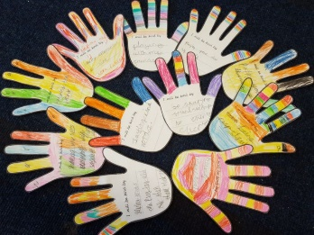

Random acts of kindness in your home
Can you show one or more acts of kindness a day?
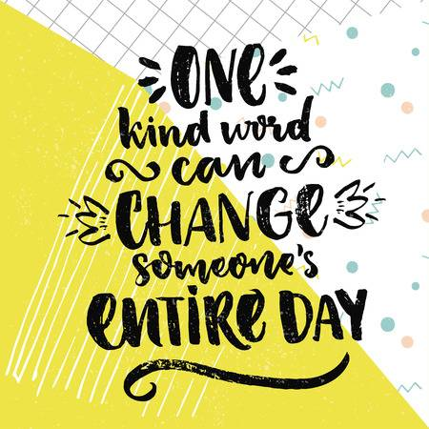
Some examples:
- Say something positive to someone
- Decorate a kindness rock and give as a gift
- Give a hug
- Hold the door for someone
- Draw a picture for someone
- Say ‘I love you’
- Clean up without being asked
- Leave a thank you note
- Say please and thank you
- Read someone a story

Here are some activities to explore the theme ‘Being Ourselves’
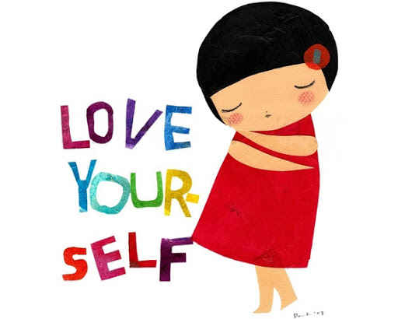

Activity 1
What makes you, you?
Think of three ways you are similar to someone in your family. Think of three ways you are different from someone in your family. Focus on what you enjoy, what they are good at and what makes you special.
Example:
“Just like ________ I love running and we are both good listeners but she/he likes playing tennis and is very funny where as I prefer singing and am very patient.”

Celebrate what makes you unique!
Use your similarities and differences to create a poster with the title ‘All about me’
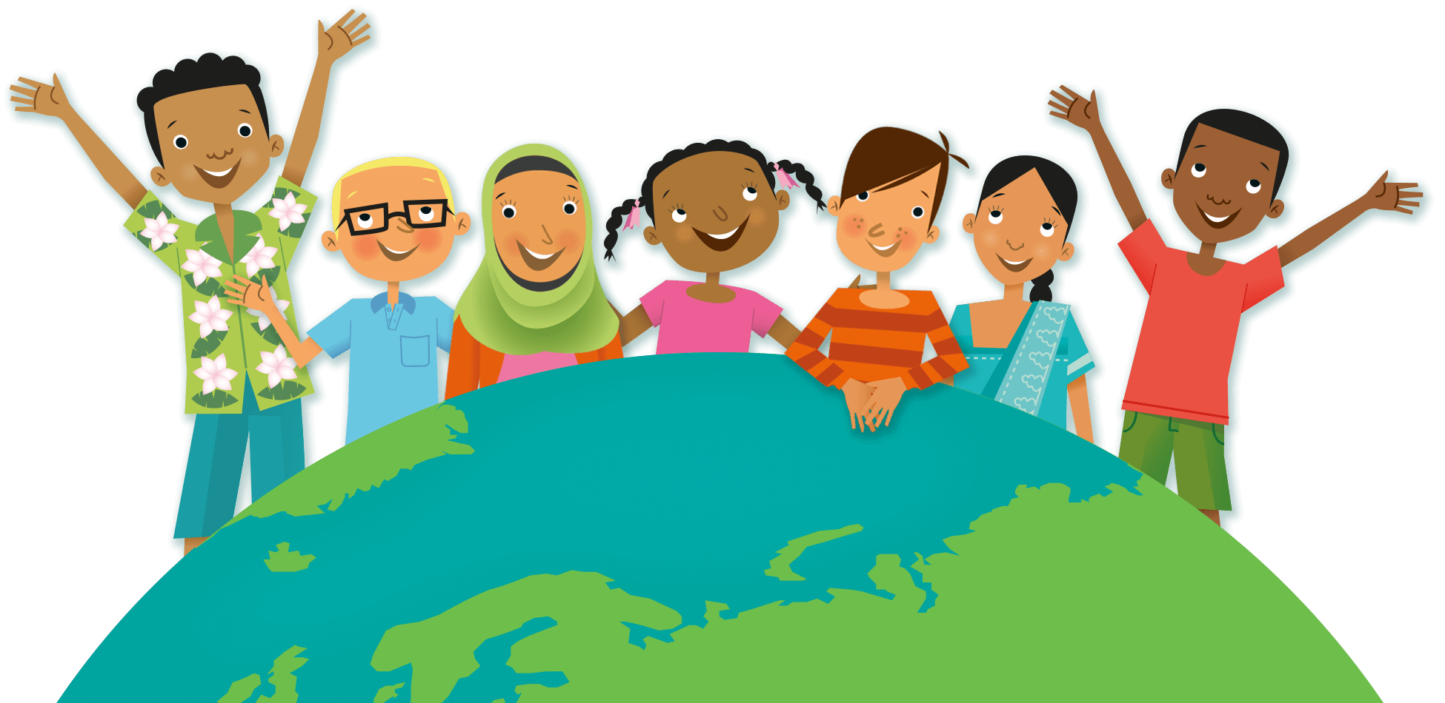
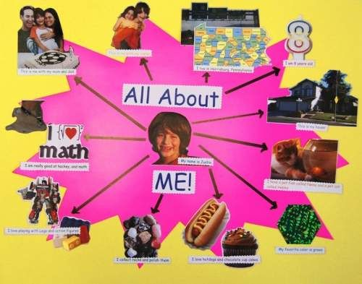
You could draw yourself in the middle and write information around the edges.

Here are some activities to explore the theme ‘Healthy inside and out’

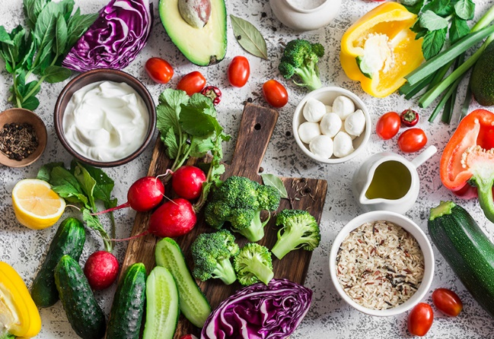
Connecting through food
Activity 1
How does food affect our bodies?
Make a list of all the foods which help our bodies to be healthy and explain why. You could draw pictures and label them.
e.g. eating fruit and vegetables makes us strong and stops us getting ill.

Activity 2
Sometimes we forget how important food is for our minds – and how it much it plays a role in our lives!
Think about when we use food to celebrate and connect with others…
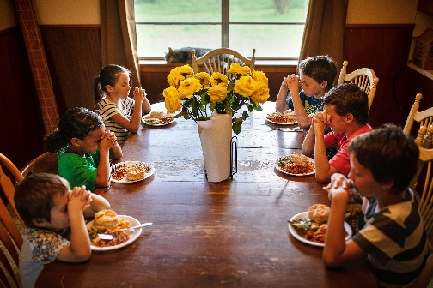
For example
- A morning cup of tea with a family member
- A slice of birthday cake to celebrate
- Christmas dinner celebrations
- Eid celebrations
- Diwali sweets during Diwlai celebrations

How do your family use food to celebrate?
Make a poster about the role of food in your house and how it helps well-being and brings your family together.
Or

How do people around the world use food to celebrate and connect with others?
Make a poster about the role of food in different cultures and how it helps wellbeing and brings people together.

